Filed by CECO Environmental Corp. Pursuant to Rule 425 under the Securities Act of 1933,
and deemed filed pursuant to Rule 14a-12 under the Securities Exchange Act of 1934
Subject Company: Thermon Group Holdings, Inc.
Commission File No.: 001-35159

 | 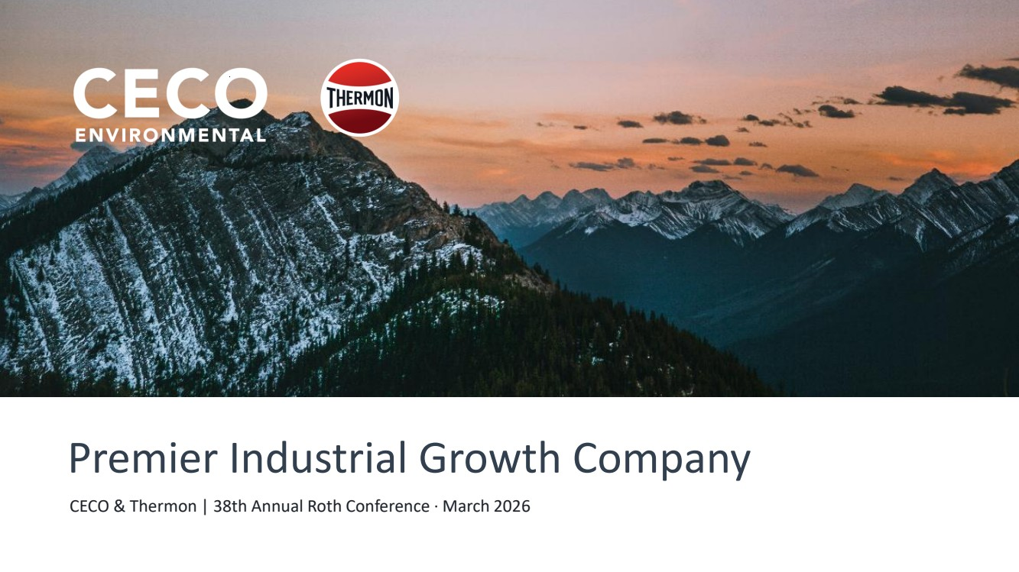 | CECO & Thermon | 38th Annual Roth Conference · March 2026 Premier Industrial Growth Company
 | 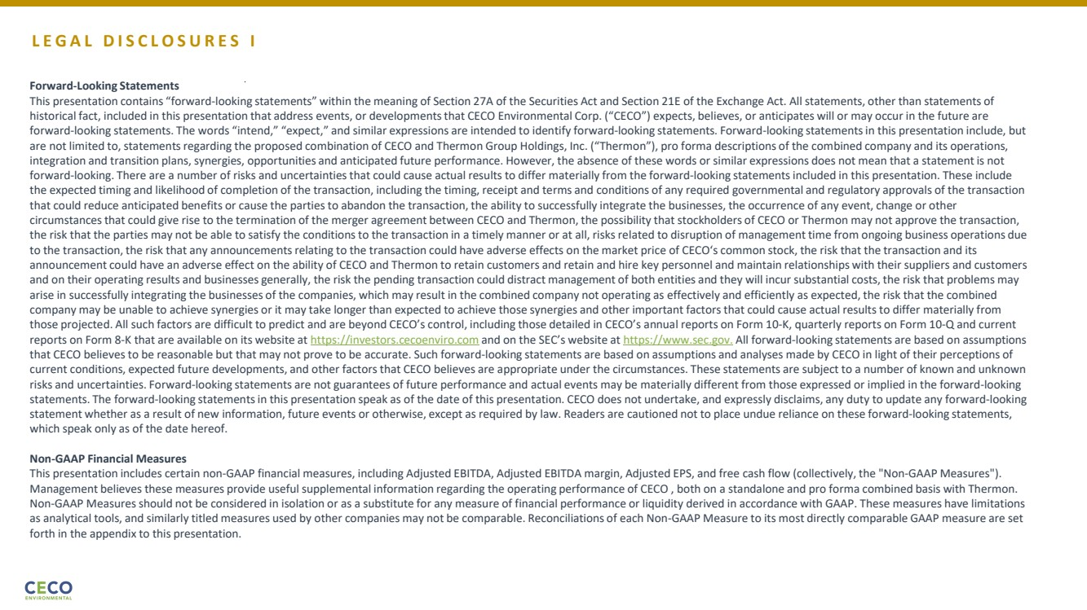 | L E G A L D I S C L O S U R E S I Forward-Looking Statements This presentation contains “forward-looking statements” within the meaning of Section 27A of the Securities Act and Section 21E of the Exchange Act. All statements, other than statements of historical fact, included in this presentation that address events, or developments that CECO Environmental Corp. (“CECO”) expects, believes, or anticipates will or may occur in the future are forward-looking statements. The words “intend,” “expect,” and similar expressions are intended to identify forward-looking statements. Forward-looking statements in this presentation include, but are not limited to, statements regarding the proposed combination of CECO and Thermon Group Holdings, Inc. (“Thermon”), pro forma descriptions of the combined company and its operations, integration and transition plans, synergies, opportunities and anticipated future performance. However, the absence of these words or similar expressions does not mean that a statement is not forward-looking. There are a number of risks and uncertainties that could cause actual results to differ materially from the forward-looking statements included in this presentation. These include the expected timing and likelihood of completion of the transaction, including the timing, receipt and terms and conditions of any required governmental and regulatory approvals of the transaction that could reduce anticipated benefits or cause the parties to abandon the transaction, the ability to successfully integrate the businesses, the occurrence of any event, change or other circumstances that could give rise to the termination of the merger agreement between CECO and Thermon, the possibility that stockholders of CECO or Thermon may not approve the transaction, the risk that the parties may not be able to satisfy the conditions to the transaction in a timely manner or at all, risks related to disruption of management time from ongoing business operations due to the transaction, the risk that any announcements relating to the transaction could have adverse effects on the market price of CECO‘s common stock, the risk that the transaction and its announcement could have an adverse effect on the ability of CECO and Thermon to retain customers and retain and hire key personnel and maintain relationships with their suppliers and customers and on their operating results and businesses generally, the risk the pending transaction could distract management of both entities and they will incur substantial costs, the risk that problems may arise in successfully integrating the businesses of the companies, which may result in the combined company not operating as effectively and efficiently as expected, the risk that the combined company may be unable to achieve synergies or it may take longer than expected to achieve those synergies and other important factors that could cause actual results to differ materially from those projected. All such factors are difficult to predict and are beyond CECO’s control, including those detailed in CECO’s annual reports on Form 10-K, quarterly reports on Form 10-Q and current reports on Form 8-K that are available on its website at https://investors.cecoenviro.com and on the SEC’s website at https://www.sec.gov. All forward-looking statements are based on assumptions that CECO believes to be reasonable but that may not prove to be accurate. Such forward-looking statements are based on assumptions and analyses made by CECO in light of their perceptions of current conditions, expected future developments, and other factors that CECO believes are appropriate under the circumstances. These statements are subject to a number of known and unknown risks and uncertainties. Forward-looking statements are not guarantees of future performance and actual events may be materially different from those expressed or implied in the forward-looking statements. The forward-looking statements in this presentation speak as of the date of this presentation. CECO does not undertake, and expressly disclaims, any duty to update any forward-looking statement whether as a result of new information, future events or otherwise, except as required by law. Readers are cautioned not to place undue reliance on these forward-looking statements, which speak only as of the date hereof. Non-GAAP Financial Measures This presentation includes certain non-GAAP financial measures, including Adjusted EBITDA, Adjusted EBITDA margin, Adjusted EPS, and free cash flow (collectively, the "Non-GAAP Measures"). Management believes these measures provide useful supplemental information regarding the operating performance of CECO , both on a standalone and pro forma combined basis with Thermon. Non-GAAP Measures should not be considered in isolation or as a substitute for any measure of financial performance or liquidity derived in accordance with GAAP. These measures have limitations as analytical tools, and similarly titled measures used by other companies may not be comparable. Reconciliations of each Non-GAAP Measure to its most directly comparable GAAP measure are set forth in the appendix to this presentation.
 | 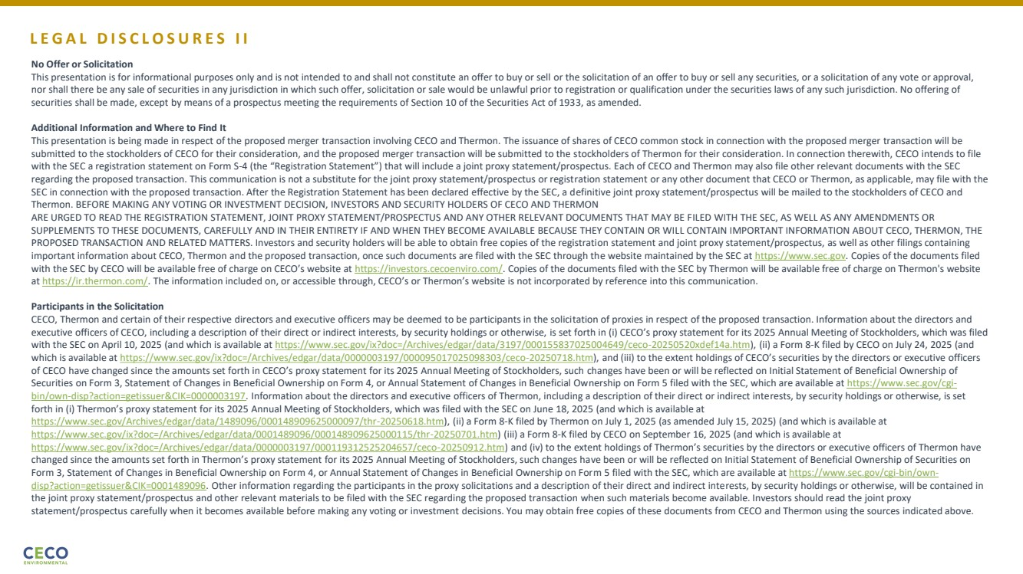 | L E G A L D I S C L O S U R E S I I No Offer or Solicitation This presentation is for informational purposes only and is not intended to and shall not constitute an offer to buy or sell or the solicitation of an offer to buy or sell any securities, or a solicitation of any vote or approval, nor shall there be any sale of securities in any jurisdiction in which such offer, solicitation or sale would be unlawful prior to registration or qualification under the securities laws of any such jurisdiction. No offering of securities shall be made, except by means of a prospectus meeting the requirements of Section 10 of the Securities Act of 1933, as amended. Additional Information and Where to Find It This presentation is being made in respect of the proposed merger transaction involving CECO and Thermon. The issuance of shares of CECO common stock in connection with the proposed merger transaction will be submitted to the stockholders of CECO for their consideration, and the proposed merger transaction will be submitted to the stockholders of Thermon for their consideration. In connection therewith, CECO intends to file with the SEC a registration statement on Form S-4 (the “Registration Statement”) that will include a joint proxy statement/prospectus. Each of CECO and Thermon may also file other relevant documents with the SEC regarding the proposed transaction. This communication is not a substitute for the joint proxy statement/prospectus or registration statement or any other document that CECO or Thermon, as applicable, may file with the SEC in connection with the proposed transaction. After the Registration Statement has been declared effective by the SEC, a definitive joint proxy statement/prospectus will be mailed to the stockholders of CECO and Thermon. BEFORE MAKING ANY VOTING OR INVESTMENT DECISION, INVESTORS AND SECURITY HOLDERS OF CECO AND THERMON ARE URGED TO READ THE REGISTRATION STATEMENT, JOINT PROXY STATEMENT/PROSPECTUS AND ANY OTHER RELEVANT DOCUMENTS THAT MAY BE FILED WITH THE SEC, AS WELL AS ANY AMENDMENTS OR SUPPLEMENTS TO THESE DOCUMENTS, CAREFULLY AND IN THEIR ENTIRETY IF AND WHEN THEY BECOME AVAILABLE BECAUSE THEY CONTAIN OR WILL CONTAIN IMPORTANT INFORMATION ABOUT CECO, THERMON, THE PROPOSED TRANSACTION AND RELATED MATTERS. Investors and security holders will be able to obtain free copies of the registration statement and joint proxy statement/prospectus, as well as other filings containing important information about CECO, Thermon and the proposed transaction, once such documents are filed with the SEC through the website maintained by the SEC at https://www.sec.gov. Copies of the documents filed with the SEC by CECO will be available free of charge on CECO’s website at https://investors.cecoenviro.com/. Copies of the documents filed with the SEC by Thermon will be available free of charge on Thermon's website at https://ir.thermon.com/. The information included on, or accessible through, CECO’s or Thermon’s website is not incorporated by reference into this communication. Participants in the Solicitation CECO, Thermon and certain of their respective directors and executive officers may be deemed to be participants in the solicitation of proxies in respect of the proposed transaction. Information about the directors and executive officers of CECO, including a description of their direct or indirect interests, by security holdings or otherwise, is set forth in (i) CECO’s proxy statement for its 2025 Annual Meeting of Stockholders, which was filed with the SEC on April 10, 2025 (and which is available at https://www.sec.gov/ix?doc=/Archives/edgar/data/3197/000155837025004649/ceco-20250520xdef14a.htm), (ii) a Form 8-K filed by CECO on July 24, 2025 (and which is available at https://www.sec.gov/ix?doc=/Archives/edgar/data/0000003197/000095017025098303/ceco-20250718.htm), and (iii) to the extent holdings of CECO’s securities by the directors or executive officers of CECO have changed since the amounts set forth in CECO’s proxy statement for its 2025 Annual Meeting of Stockholders, such changes have been or will be reflected on Initial Statement of Beneficial Ownership of Securities on Form 3, Statement of Changes in Beneficial Ownership on Form 4, or Annual Statement of Changes in Beneficial Ownership on Form 5 filed with the SEC, which are available at https://www.sec.gov/cgi-bin/own-disp?action=getissuer&CIK=0000003197. Information about the directors and executive officers of Thermon, including a description of their direct or indirect interests, by security holdings or otherwise, is set forth in (i) Thermon’s proxy statement for its 2025 Annual Meeting of Stockholders, which was filed with the SEC on June 18, 2025 (and which is available at https://www.sec.gov/Archives/edgar/data/1489096/000148909625000097/thr-20250618.htm), (ii) a Form 8-K filed by Thermon on July 1, 2025 (as amended July 15, 2025) (and which is available at https://www.sec.gov/ix?doc=/Archives/edgar/data/0001489096/000148909625000115/thr-20250701.htm) (iii) a Form 8-K filed by CECO on September 16, 2025 (and which is available at https://www.sec.gov/ix?doc=/Archives/edgar/data/0000003197/000119312525204657/ceco-20250912.htm) and (iv) to the extent holdings of Thermon’s securities by the directors or executive officers of Thermon have changed since the amounts set forth in Thermon’s proxy statement for its 2025 Annual Meeting of Stockholders, such changes have been or will be reflected on Initial Statement of Beneficial Ownership of Securities on Form 3, Statement of Changes in Beneficial Ownership on Form 4, or Annual Statement of Changes in Beneficial Ownership on Form 5 filed with the SEC, which are available at https://www.sec.gov/cgi-bin/own-disp?action=getissuer&CIK=0001489096. Other information regarding the participants in the proxy solicitations and a description of their direct and indirect interests, by security holdings or otherwise, will be contained in the joint proxy statement/prospectus and other relevant materials to be filed with the SEC regarding the proposed transaction when such materials become available. Investors should read the joint proxy statement/prospectus carefully when it becomes available before making any voting or investment decisions. You may obtain free copies of these documents from CECO and Thermon using the sources indicated above.
 | 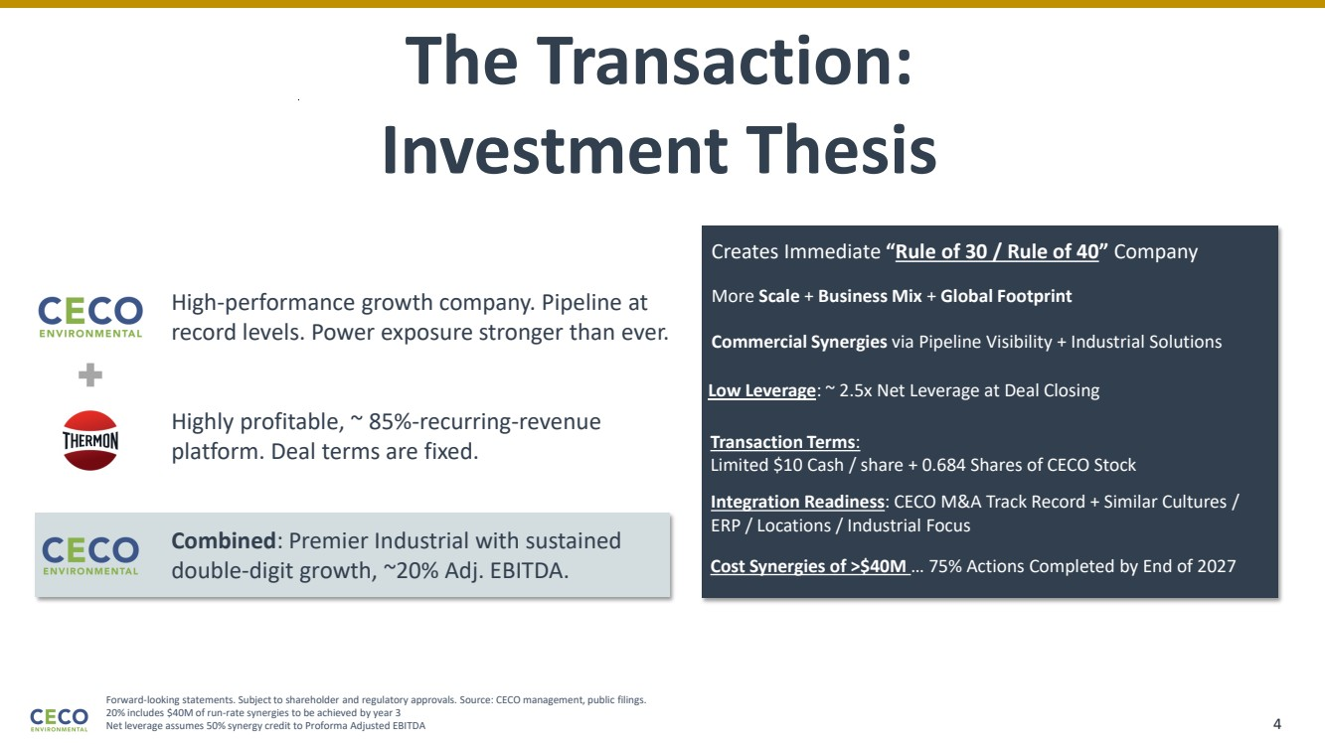 | Forward-looking statements. Subject to shareholder and regulatory approvals. Source: CECO management, public filings. 20% includes $40M of run-rate synergies to be achieved by year 3 Net leverage assumes 50% synergy credit to Proforma Adjusted EBITDA The Transaction: Investment Thesis High-performance growth company. Pipeline at record levels. Power exposure stronger than ever. Highly profitable, ~ 85%-recurring-revenue platform. Deal terms are fixed. Combined: Premier Industrial with sustained double-digit growth, ~20% Adj. EBITDA. Creates Immediate “Rule of 30 / Rule of 40” Company Low Leverage: ~ 2.5x Net Leverage at Deal Closing Transaction Terms: Limited $10 Cash / share + 0.684 Shares of CECO Stock More Scale + Business Mix + Global Footprint Commercial Synergies via Pipeline Visibility + Industrial Solutions Integration Readiness: CECO M&A Track Record + Similar Cultures / ERP / Locations / Industrial Focus Cost Synergies of >$40M … 75% Actions Completed by End of 2027 4
 | 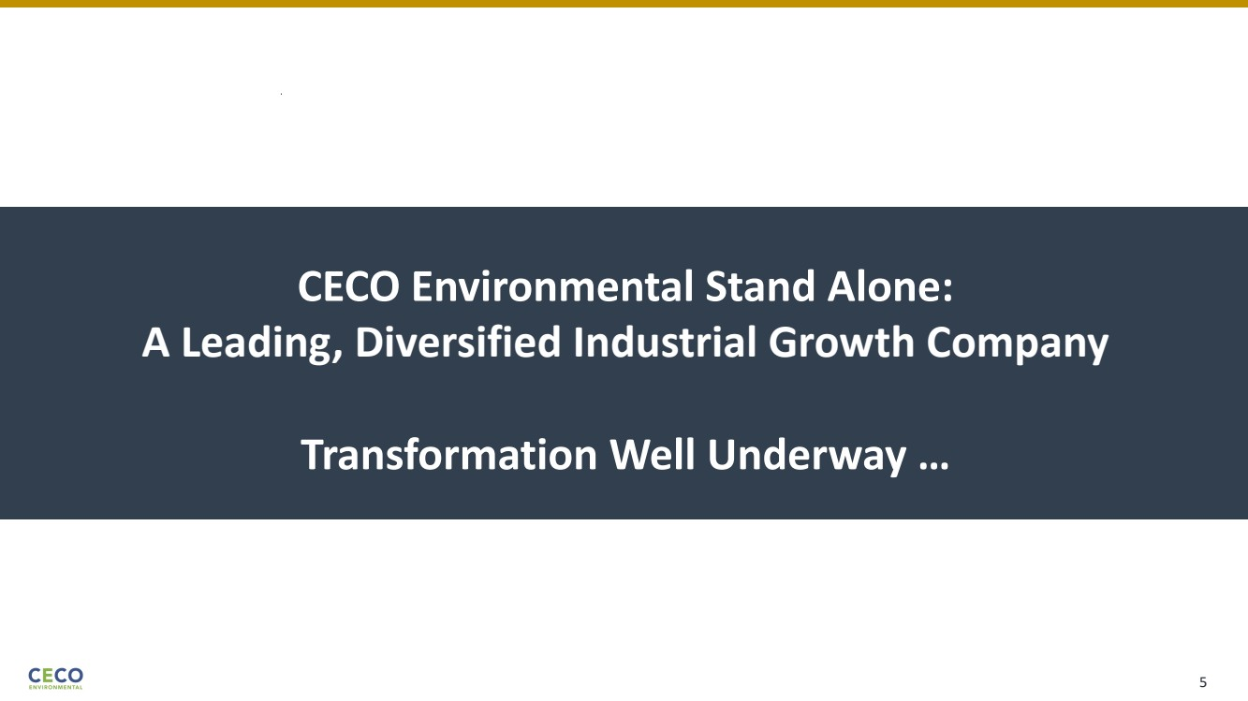 | CECO Environmental Stand Alone: A Leading, Diversified Industrial Growth Company Transformation Well Underway … 5
 | 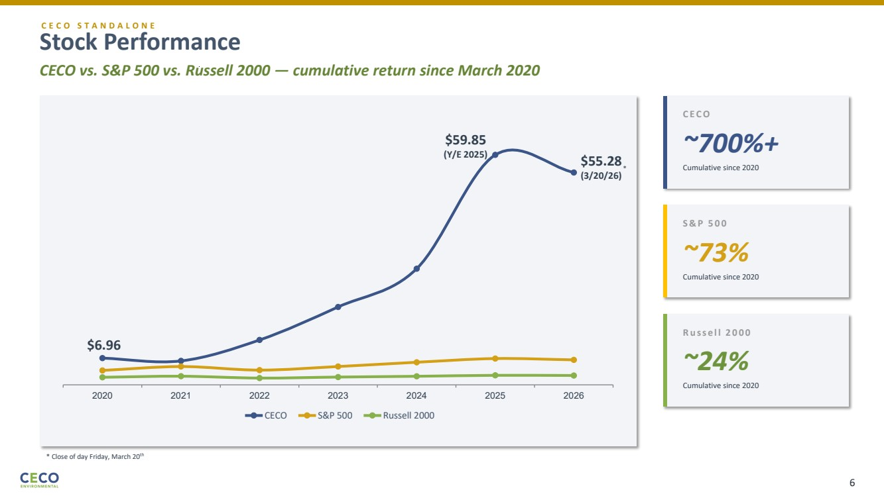 | Stock Performance CECO vs. S&P 500 vs. Russell 2000 — cumulative return since March 2020 2020 2021 2022 2023 2024 2025 2026 CECO S&P 500 Russell 2000 C E C O ~700%+ Cumulative since 2020 S & P 5 0 0 ~73% Cumulative since 2020 R u s s e l l 2 0 0 0 ~24% Cumulative since 2020 $6.96 $59.85 (Y/E 2025) 6 $55.28 (3/20/26) * * Close of day Friday, March 20th C E C O S T A N D A L O N E
 | 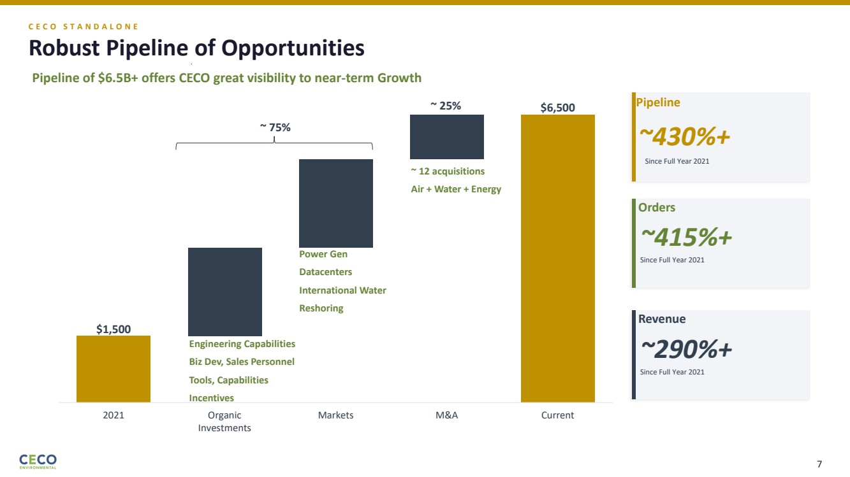 | $1,500 $6,500 2021 Organic Investments Markets M&A Current C E C O S T A N D A L O N E Robust Pipeline of Opportunities Pipeline of $6.5B+ offers CECO great visibility to near-term Growth ~ 25% ~ 75% ~ 12 acquisitions Air + Water + Energy Power Gen Datacenters International Water Reshoring Engineering Capabilities Biz Dev, Sales Personnel Tools, Capabilities Incentives ~430%+ Since Full Year 2021 Pipeline ~415%+ Orders Since Full Year 2021 ~290%+ Revenue Since Full Year 2021 7
 | 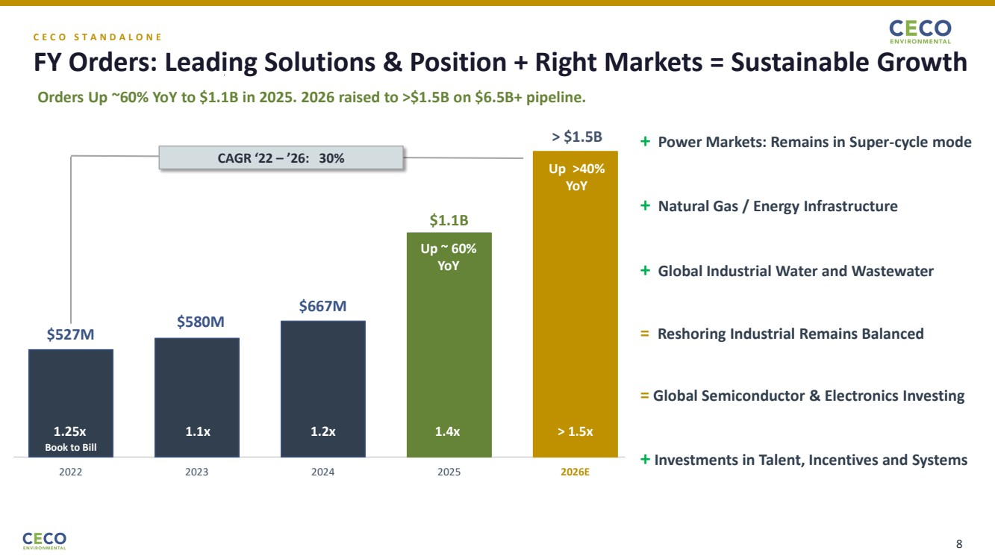 | C E C O S T A N D A L O N E FY Orders: Leading Solutions & Position + Right Markets = Sustainable Growth Orders Up ~60% YoY to $1.1B in 2025. 2026 raised to >$1.5B on $6.5B+ pipeline. $527M 1.25x 2022 $580M 1.1x 2023 $667M 1.2x 2024 $1.1B 1.4x 2025 > $1.5B > 1.5x 2026E ~30% Book to Bill CAGR ‘22 – ’26: 30% + Power Markets: Remains in Super-cycle mode + Natural Gas / Energy Infrastructure + Global Industrial Water and Wastewater = Reshoring Industrial Remains Balanced = Global Semiconductor & Electronics Investing + Investments in Talent, Incentives and Systems Up ~ 60% YoY Up >40% YoY 8
 | 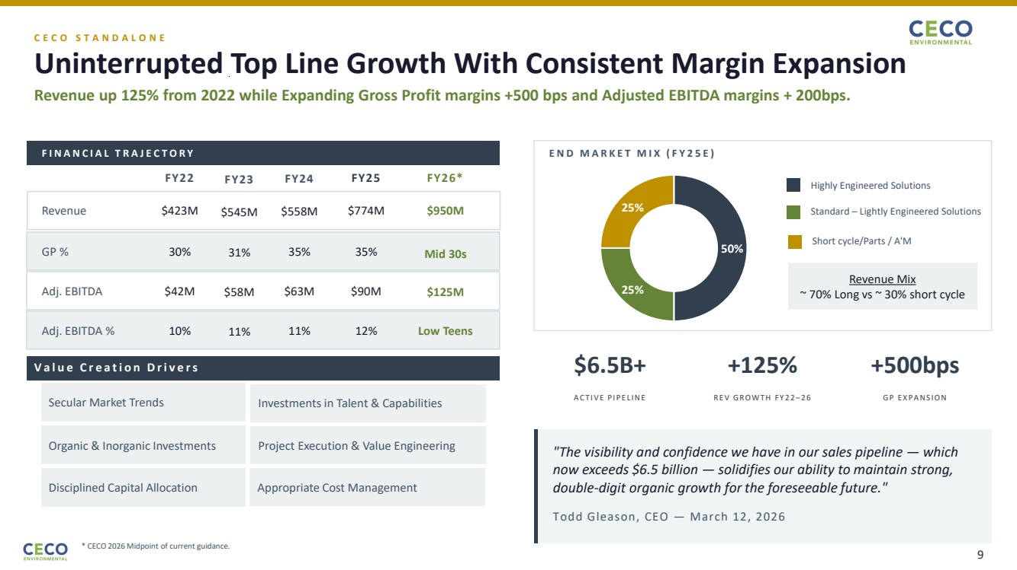 | C E C O S T A N D A L O N E Uninterrupted Top Line Growth With Consistent Margin Expansion Revenue up 125% from 2022 while Expanding Gross Profit margins +500 bps and Adjusted EBITDA margins + 200bps. F I N A N C I A L T R A J E C T O R Y FY22 FY23 FY24 FY25 Revenue $423M $545M $558M $774M GP % 30% 31% 35% 35% Adj. EBITDA $42M $58M $63M $90M Adj. EBITDA % 10% 11% 11% 12% E N D M A R K E T M I X ( F Y 2 5 E ) Highly Engineered Solutions Standard – Lightly Engineered Solutions Short cycle/Parts / A'M $6.5B+ A C T I V E P I P E L I N E +125% R E V G R O W T H F Y 2 2 –2 6 +500bps G P E X P A N S I O N "The visibility and confidence we have in our sales pipeline — which now exceeds $6.5 billion — solidifies our ability to maintain strong, double-digit organic growth for the foreseeable future." Todd Gleason, CEO — March 12, 2026 50% 25% 25% Revenue Mix ~ 70% Long vs ~ 30% short cycle * CECO 2026 Midpoint of current guidance. FY26* $950M Mid 30s $125M Low Teens Secular Market Trends Organic & Inorganic Investments V a l u e C r e a t i o n D r i v e r s Investments in Talent & Capabilities Disciplined Capital Allocation Project Execution & Value Engineering Appropriate Cost Management 9
 | 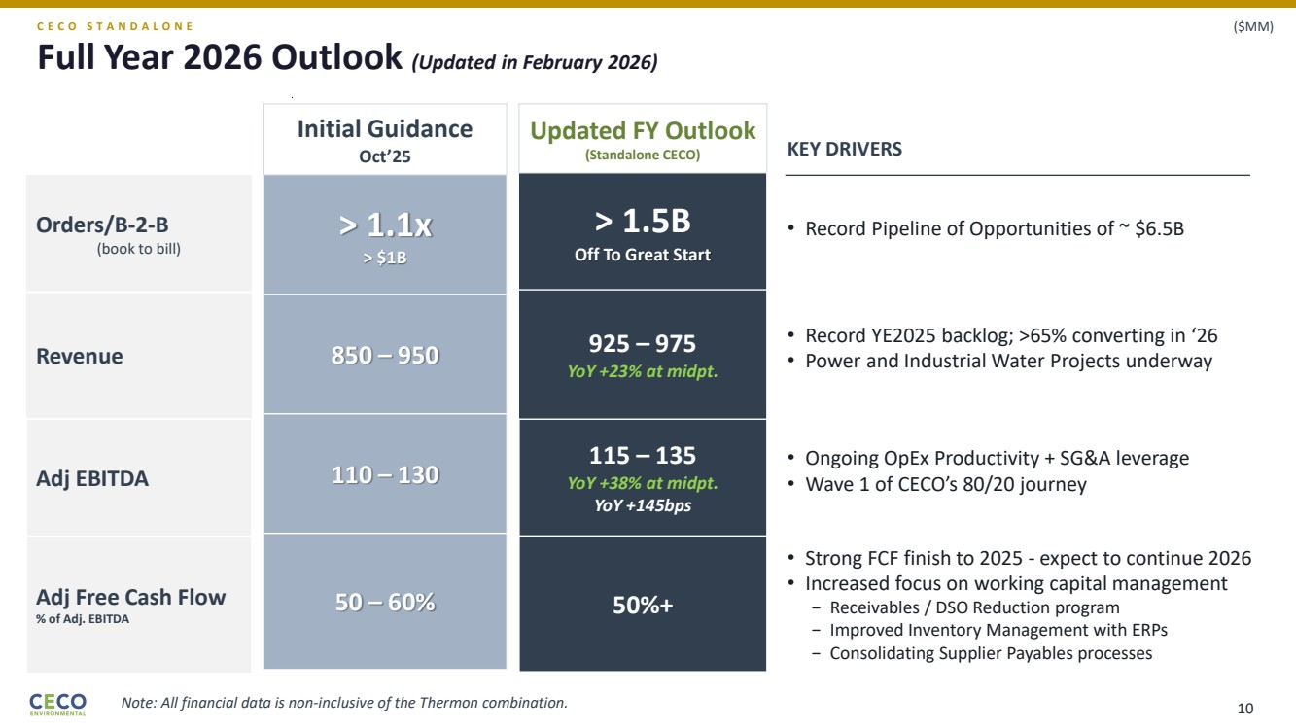 | Full Year 2026 Outlook (Updated in February 2026) Initial Guidance Oct’25 > 1.1x > $1B 850 – 950 110 – 130 50 – 60% Updated FY Outlook (Standalone CECO) > 1.5B Off To Great Start 925 – 975 YoY +23% at midpt. 115 – 135 YoY +38% at midpt. YoY +145bps 50%+ • Record YE2025 backlog; >65% converting in ‘26 • Power and Industrial Water Projects underway • Ongoing OpEx Productivity + SG&A leverage • Wave 1 of CECO’s 80/20 journey • Strong FCF finish to 2025 - expect to continue 2026 • Increased focus on working capital management − Receivables / DSO Reduction program − Improved Inventory Management with ERPs − Consolidating Supplier Payables processes Orders/B-2-B (book to bill) Revenue Adj EBITDA Adj Free Cash Flow % of Adj. EBITDA • Record Pipeline of Opportunities of ~ $6.5B C E C O S T A N D A L O N E ($MM) KEY DRIVERS Note: All financial data is non-inclusive of the Thermon combination. 10
 | 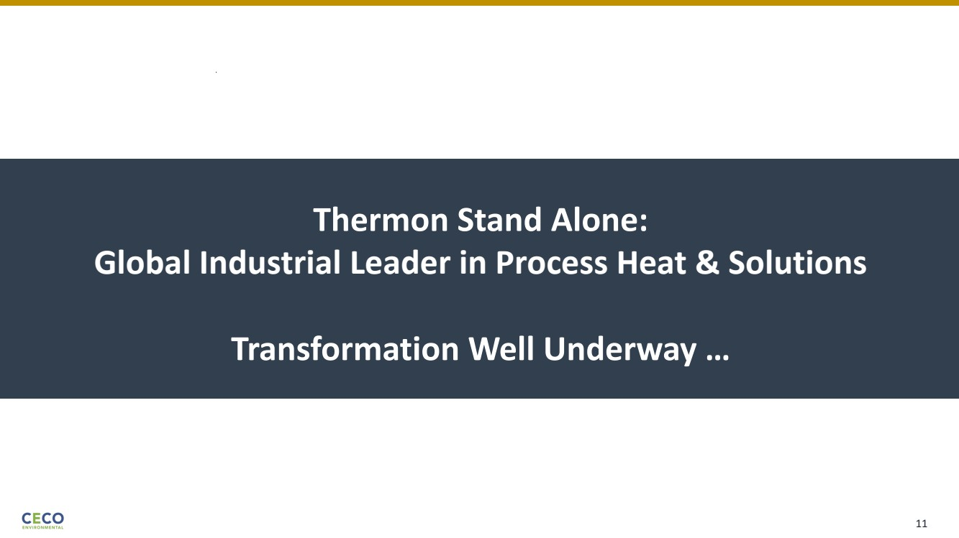 | Thermon Stand Alone: Global Industrial Leader in Process Heat & Solutions Transformation Well Underway … 11
 | 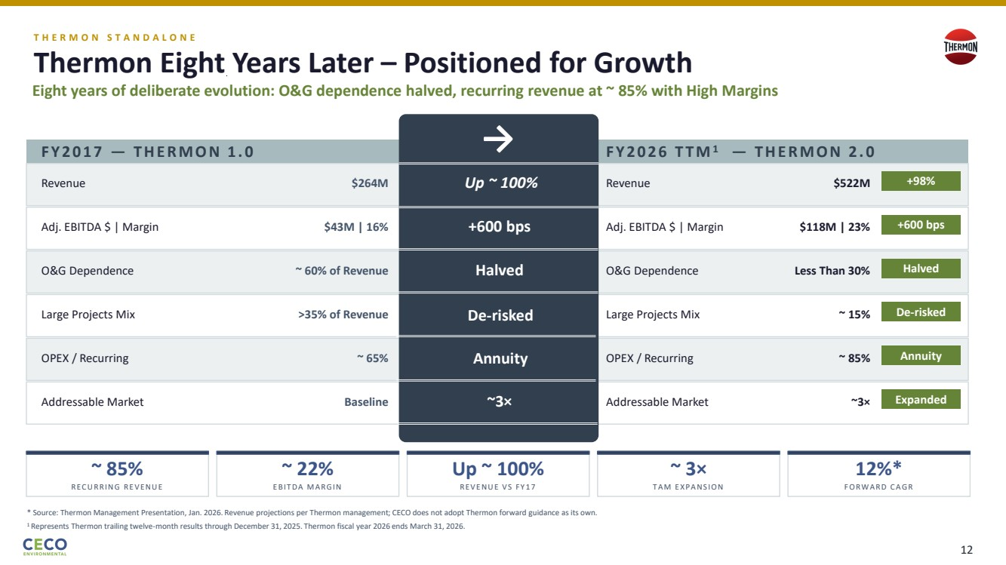 | T H E R M O N S T A N D A L O N E Thermon Eight Years Later – Positioned for Growth Eight years of deliberate evolution: O&G dependence halved, recurring revenue at ~ 85% with High Margins F Y 2 0 1 7 — T H E R M O N 1 . 0 Revenue $264M Adj. EBITDA $ | Margin $43M | 16% O&G Dependence ~ 60% of Revenue Large Projects Mix >35% of Revenue OPEX / Recurring ~ 65% Addressable Market Baseline F Y 2 0 2 6 T T M1 — T H E R M O N 2 . 0 Revenue $522M +98% Adj. EBITDA $ | Margin $118M | 23% +600 bps O&G Dependence Less Than 30% Halved Large Projects Mix ~ 15% De-risked OPEX / Recurring ~ 85% Annuity Addressable Market ~3× Expanded ~ 85% R E C U R R I N G R E V E N U E ~ 22% E BI T D A M A R G I N Up ~ 100% R E V E N U E V S F Y 1 7 ~ 3× T A M E X P A N S I O N 12%* F O R W A R D C A G R * Source: Thermon Management Presentation, Jan. 2026. Revenue projections per Thermon management; CECO does not adopt Thermon forward guidance as its own. → Up ~ 100% +600 bps Halved De-risked Annuity ~3× 1 Represents Thermon trailing twelve-month results through December 31, 2025. Thermon fiscal year 2026 ends March 31, 2026. 12
 | 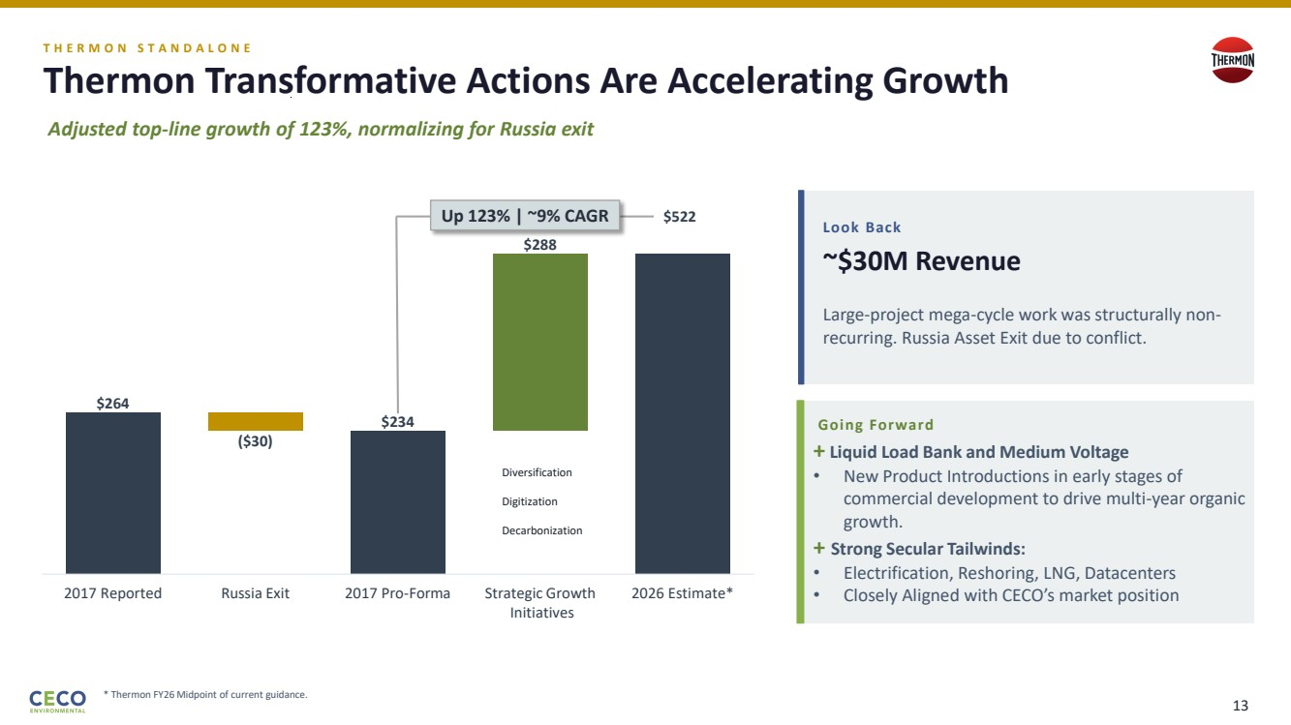 | T H E R M O N S T A N D A L O N E Thermon Transformative Actions Are Accelerating Growth Adjusted top-line growth of 123%, normalizing for Russia exit Look Back ~$30M Revenue Large-project mega-cycle work was structurally non-recurring. Russia Asset Exit due to conflict. Going Forward + Liquid Load Bank and Medium Voltage • New Product Introductions in early stages of commercial development to drive multi-year organic growth. + Strong Secular Tailwinds: • Electrification, Reshoring, LNG, Datacenters • Closely Aligned with CECO’s market position $264 ($30) $234 $288 2017 Reported Russia Exit 2017 Pro-Forma Strategic Growth Initiatives 2026 Estimate* Diversification Digitization Decarbonization Up 123% | ~9% CAGR $522 * Thermon FY26 Midpoint of current guidance. 13
 | 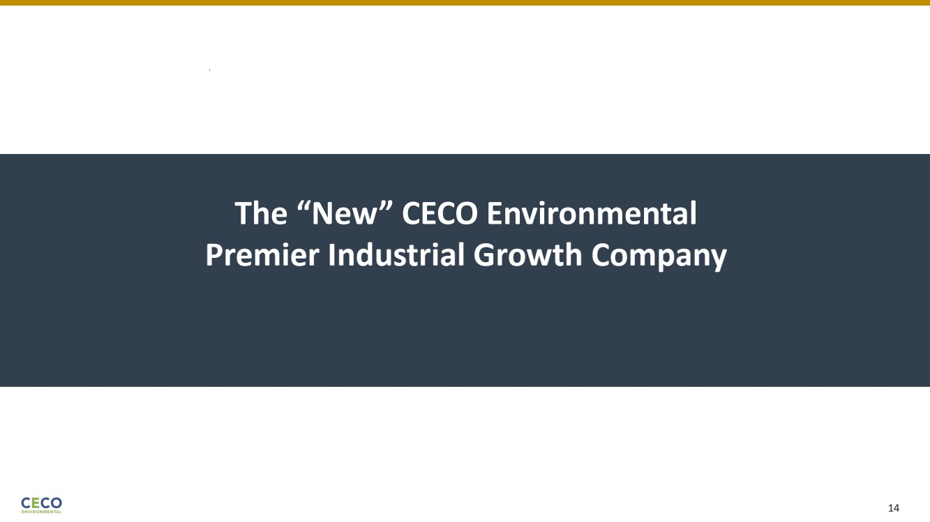 | The “New” CECO Environmental Premier Industrial Growth Company 14
 | 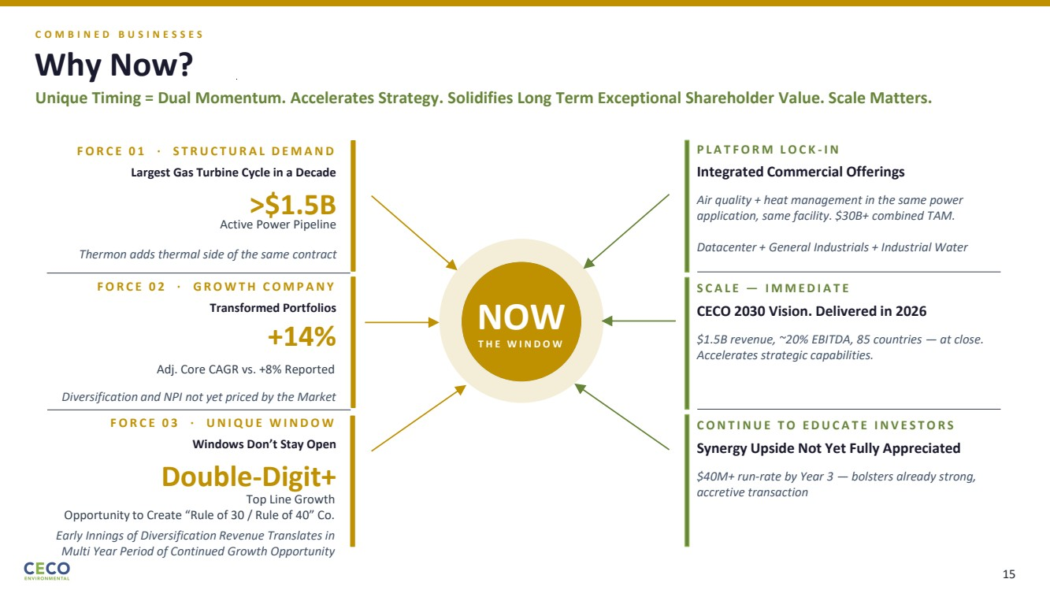 | C O M B I N E D B U S I N E S S E S Why Now? Unique Timing = Dual Momentum. Accelerates Strategy. Solidifies Long Term Exceptional Shareholder Value. Scale Matters. NOW T H E W I N D O W F O R C E 0 1 · S T R U C T U R A L D E M A N D Largest Gas Turbine Cycle in a Decade >$1.5B Active Power Pipeline Thermon adds thermal side of the same contract F O R C E 0 2 · G R O W T H C O M P A N Y Transformed Portfolios +14% Adj. Core CAGR vs. +8% Reported Diversification and NPI not yet priced by the Market F O R C E 0 3 · U N I Q U E W I N D O W Windows Don’t Stay Open Double-Digit+ Top Line Growth Opportunity to Create “Rule of 30 / Rule of 40” Co. Early Innings of Diversification Revenue Translates in Multi Year Period of Continued Growth Opportunity P L A T F O R M L O C K - I N Integrated Commercial Offerings Air quality + heat management in the same power application, same facility. $30B+ combined TAM. Datacenter + General Industrials + Industrial Water S C A L E — I M M E D I A T E CECO 2030 Vision. Delivered in 2026 $1.5B revenue, ~20% EBITDA, 85 countries — at close. Accelerates strategic capabilities. C O N T I N U E T O E D U C A T E I N V E S T O R S Synergy Upside Not Yet Fully Appreciated $40M+ run-rate by Year 3 — bolsters already strong, accretive transaction 15
 | 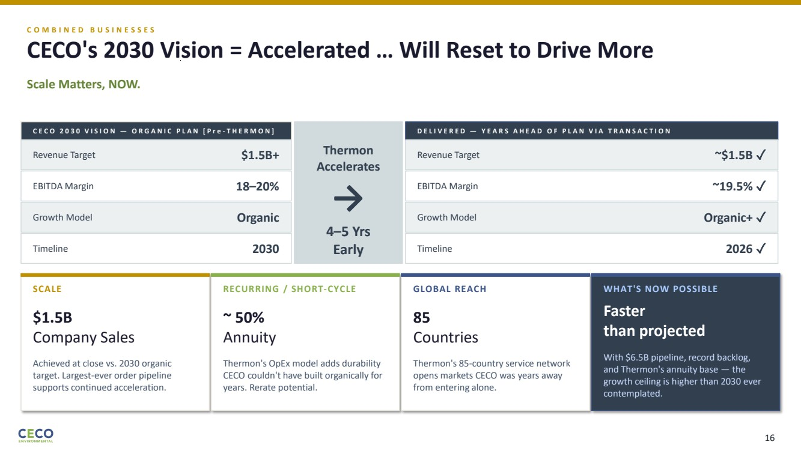 | C O M B I N E D B U S I N E S S E S CECO's 2030 Vision = Accelerated … Will Reset to Drive More Scale Matters, NOW. C E C O 2 0 3 0 V I S I O N — O R G A N I C P L A N [ P r e - T H E R M O N ] Revenue Target $1.5B+ EBITDA Margin 18–20% Growth Model Organic Timeline 2030 Thermon Accelerates → 4–5 Yrs Early D E L I V E R E D — Y E A R S A H E A D O F P L A N V I A T R A N S A C T I O N Revenue Target ~$1.5B ✓ EBITDA Margin ~19.5% ✓ Growth Model Organic+ ✓ Timeline 2026 ✓ SCALE $1.5B Company Sales Achieved at close vs. 2030 organic target. Largest-ever order pipeline supports continued acceleration. RECURRING / SHORT-CYCLE ~ 50% Annuity Thermon's OpEx model adds durability CECO couldn't have built organically for years. Rerate potential. GLOBAL REACH 85 Countries Thermon's 85-country service network opens markets CECO was years away from entering alone. WHAT'S NOW POSSIBLE Faster than projected With $6.5B pipeline, record backlog, and Thermon's annuity base — the growth ceiling is higher than 2030 ever contemplated. 16
 | 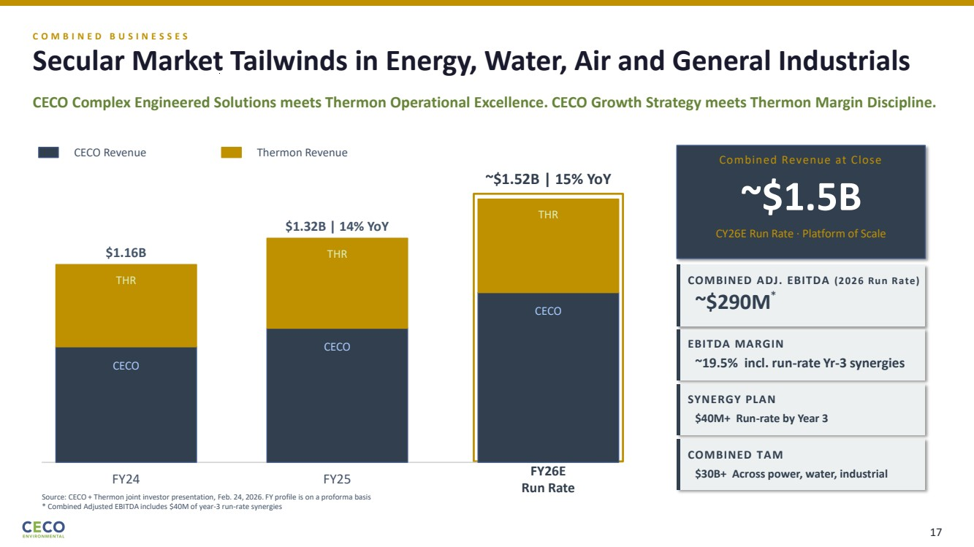 | C O M B I N E D B U S I N E S S E S Secular Market Tailwinds in Energy, Water, Air and General Industrials CECO Complex Engineered Solutions meets Thermon Operational Excellence. CECO Growth Strategy meets Thermon Margin Discipline. CECO Revenue Thermon Revenue Source: CECO + Thermon joint investor presentation, Feb. 24, 2026. FY profile is on a proforma basis * Combined Adjusted EBITDA includes $40M of year-3 run-rate synergies CECO THR $1.16B FY24 CECO THR $1.32B | 14% YoY FY25 CECO THR FY26E Run Rate ~$1.52B | 15% YoY Combined Revenue at Close ~$1.5B CY26E Run Rate · Platform of Scale COMBINED ADJ. EBITDA (2026 Run Rate) ~$290M EBITDA MARGIN ~19.5% incl. run-rate Yr-3 synergies SYNERGY PLAN $40M+ Run-rate by Year 3 COMBINED TAM $30B+ Across power, water, industrial * 17
 | 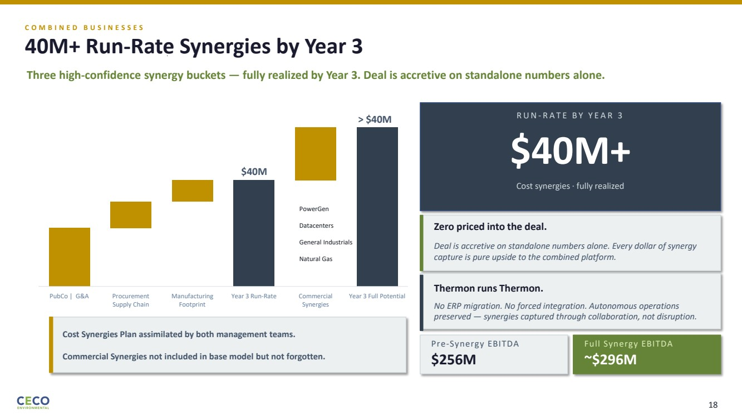 | C O M B I N E D B U S I N E S S E S 40M+ Run-Rate Synergies by Year 3 Three high-confidence synergy buckets — fully realized by Year 3. Deal is accretive on standalone numbers alone. R U N - R A T E B Y Y E A R 3 $40M+ Cost synergies · fully realized Zero priced into the deal. Deal is accretive on standalone numbers alone. Every dollar of synergy capture is pure upside to the combined platform. Thermon runs Thermon. No ERP migration. No forced integration. Autonomous operations preserved — synergies captured through collaboration, not disruption. Pre-Synergy EBITDA $256M Full Synergy EBITDA ~$296M PubCo | G&A Procurement Supply Chain Manufacturing Footprint Year 3 Run-Rate Commercial Synergies Year 3 Full Potential $40M > $40M PowerGen Datacenters General Industrials Natural Gas Cost Synergies Plan assimilated by both management teams. Commercial Synergies not included in base model but not forgotten. 18
 | 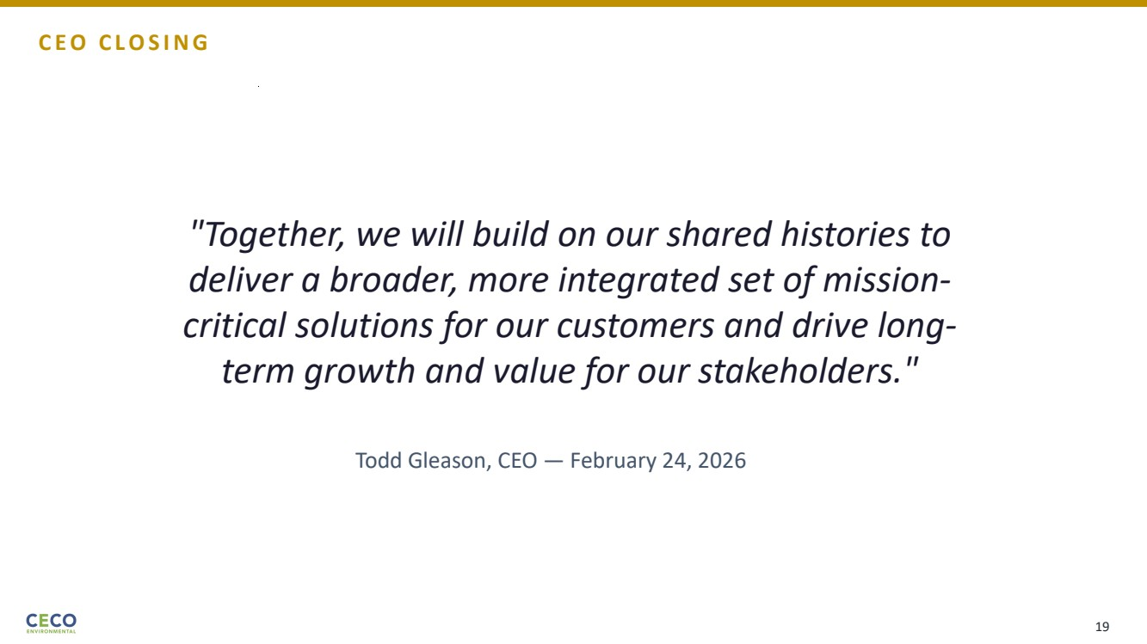 | "Together, we will build on our shared histories to deliver a broader, more integrated set of mission-critical solutions for our customers and drive long-term growth and value for our stakeholders." Todd Gleason, CEO — February 24, 2026 C E O C L O S I N G 19
 | 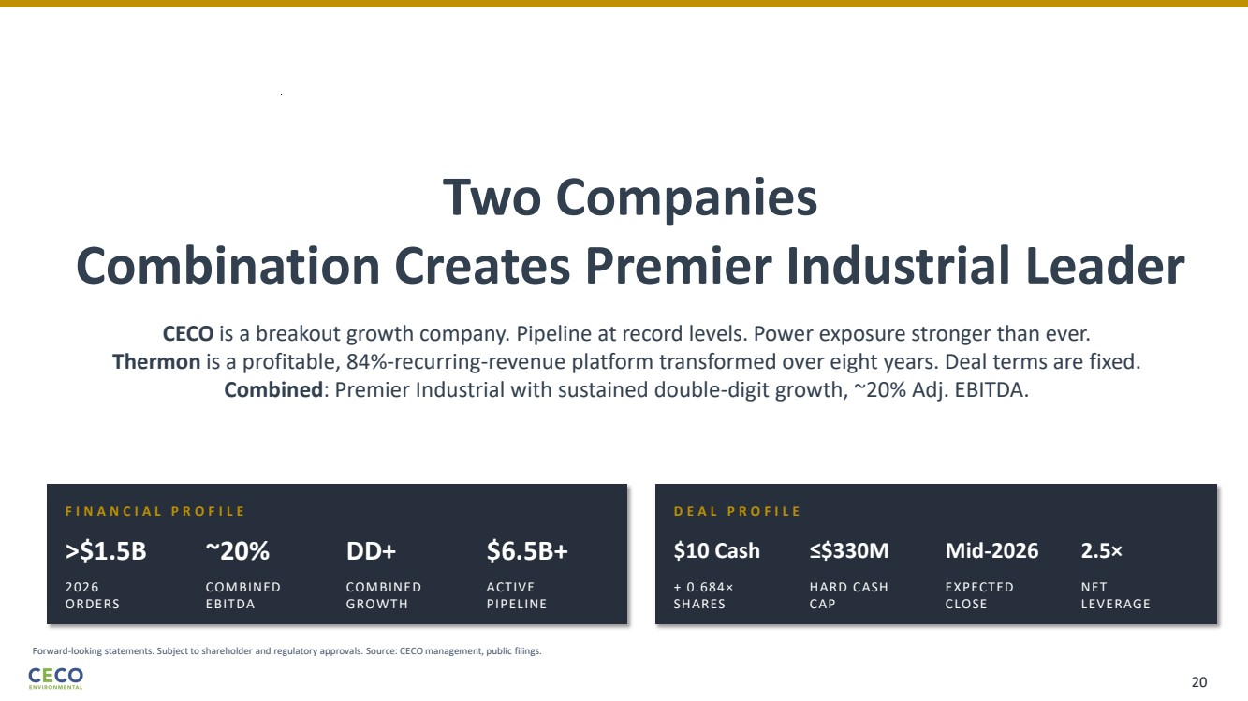 | F I N A N C I A L P R O F I L E >$1.5B 2026 ORDERS ~20% COMBINED EBITDA DD+ COMBINED GROWTH $6.5B+ ACTIVE PIPELINE D E A L P R O F I L E $10 Cash + 0.684× SHARES ≤$330M HARD CASH CAP Mid-2026 EXPECTED CLOSE 2.5× NET LEVERAGE Forward-looking statements. Subject to shareholder and regulatory approvals. Source: CECO management, public filings. Two Companies Combination Creates Premier Industrial Leader CECO is a breakout growth company. Pipeline at record levels. Power exposure stronger than ever. Thermon is a profitable, 84%-recurring-revenue platform transformed over eight years. Deal terms are fixed. Combined: Premier Industrial with sustained double-digit growth, ~20% Adj. EBITDA. 20
 | 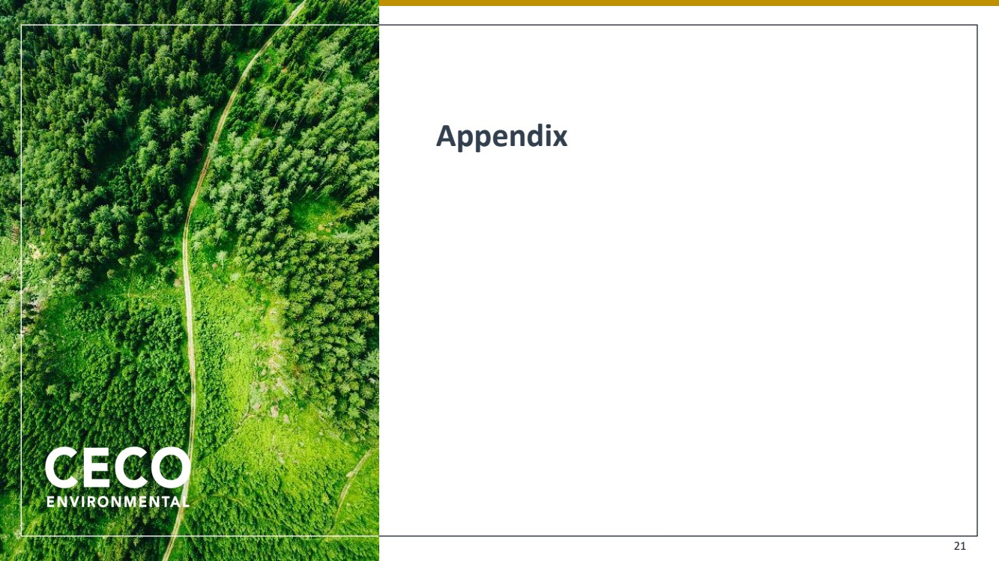 | Appendix 21
 | 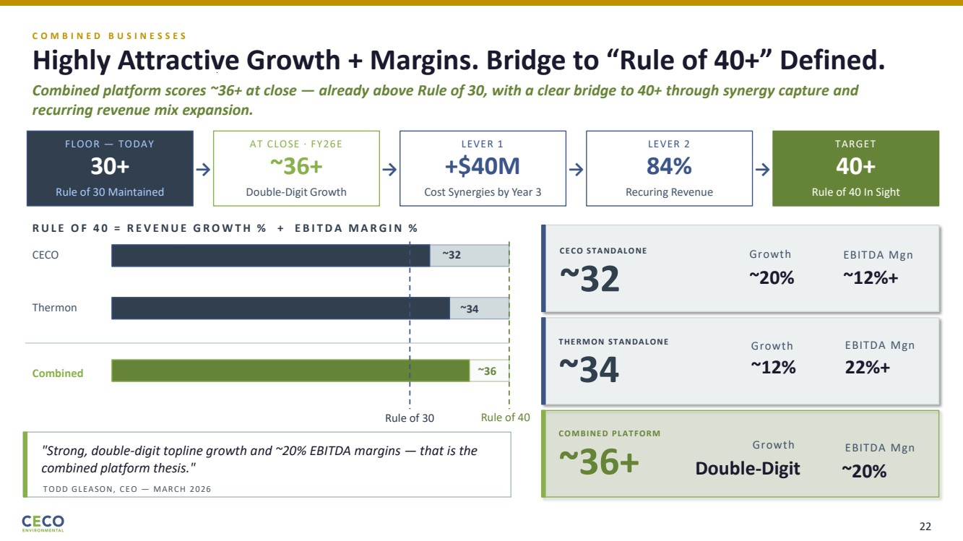 | C O M B I N E D B U S I N E S S E S Highly Attractive Growth + Margins. Bridge to “Rule of 40+” Defined. Combined platform scores ~36+ at close — already above Rule of 30, with a clear bridge to 40+ through synergy capture and recurring revenue mix expansion. FLOOR — TODAY 30+ Rule of 30 Maintained → AT CLOSE · FY26E ~36+ Double-Digit Growth → LEVER 1 +$40M Cost Synergies by Year 3 → LEVER 2 84% Recuring Revenue → TARGET 40+ Rule of 40 In Sight Rule of 40 R U L E O F 4 0 = R E V E N U E G R O W T H % + E B I T D A M A R G I N % CECO ~32 Thermon ~34 Combined ~36 Rule of 30 "Strong, double-digit topline growth and ~20% EBITDA margins — that is the combined platform thesis." TODD GLEASON, CEO — MARCH 2026 CECO STANDALONE ~32 Growth ~20% EBITDA Mgn ~12%+ THERMON STANDALONE ~34 Growth ~12% EBITDA Mgn 22%+ COMBINED PLATFORM ~36+ Growth Double-Digit EBITDA Mgn ~20% 22
 | 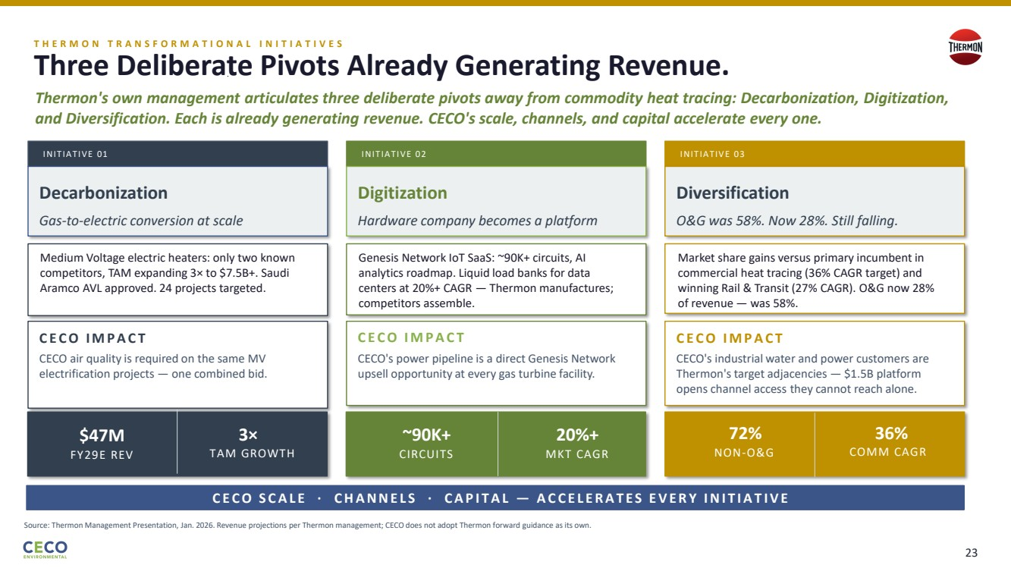 | A C T I I — T H E R M O N S T R A T E G I C D I R E C T I O N T H E R M O N T R A N S F O R M A T I O N A L I N I T I A T I V E S Three Deliberate Pivots Already Generating Revenue. Thermon's own management articulates three deliberate pivots away from commodity heat tracing: Decarbonization, Digitization, and Diversification. Each is already generating revenue. CECO's scale, channels, and capital accelerate every one. C E C O S C A L E · C H A N N E L S · C A P I T A L — A C C E L E R A T E S E V E R Y I N I T I A T I V E Source: Thermon Management Presentation, Jan. 2026. Revenue projections per Thermon management; CECO does not adopt Thermon forward guidance as its own. INITIATIVE 01 INITIATIVE 02 INITIATIV E 03 C E C O I M P A C T CECO air quality is required on the same MV electrification projects — one combined bid. C E C O I M P A C T CECO's power pipeline is a direct Genesis Network upsell opportunity at every gas turbine facility. C E C O I M P A C T CECO's industrial water and power customers are Thermon's target adjacencies — $1.5B platform opens channel access they cannot reach alone. T H E W A V E T H E W A V E Decarbonization Digitization Diversification Gas-to-electric conversion at scale Hardware company becomes a platform O&G was 58%. Now 28%. Still falling. Medium Voltage electric heaters: only two known competitors, TAM expanding 3× to $7.5B+. Saudi Aramco AVL approved. 24 projects targeted. Genesis Network IoT SaaS: ~90K+ circuits, AI analytics roadmap. Liquid load banks for data centers at 20%+ CAGR — Thermon manufactures; competitors assemble. Market share gains versus primary incumbent in commercial heat tracing (36% CAGR target) and winning Rail & Transit (27% CAGR). O&G now 28% of revenue — was 58%. $47M FY29E REV 3× TAM GROWTH ~90K+ CIRCUITS 20%+ MKT CAGR 72% NON-O&G 36% COMM CAGR 23
 | 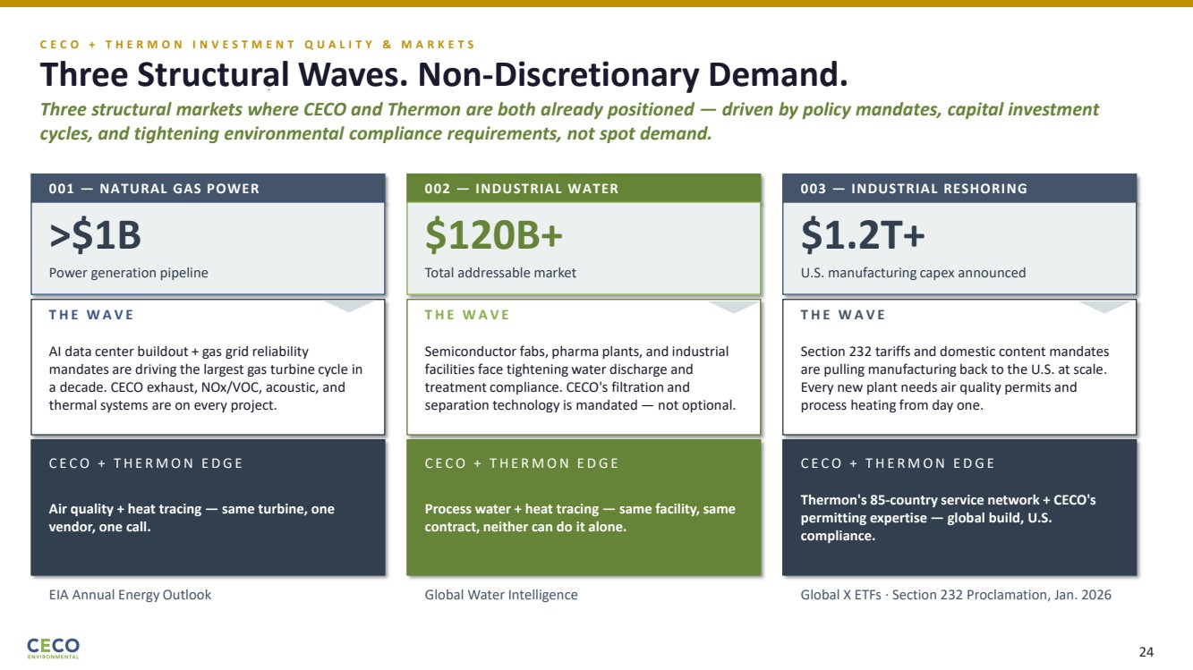 | C E C O + T H E R M O N I N V E S T M E N T Q U A L I T Y & M A R K E T S Three Structural Waves. Non-Discretionary Demand. Three structural markets where CECO and Thermon are both already positioned — driven by policy mandates, capital investment cycles, and tightening environmental compliance requirements, not spot demand. 001 — NATURAL GAS POWER >$1B Power generation pipeline T H E W A V E AI data center buildout + gas grid reliability mandates are driving the largest gas turbine cycle in a decade. CECO exhaust, NOx/VOC, acoustic, and thermal systems are on every project. C E C O + T H E R M O N E D G E Air quality + heat tracing — same turbine, one vendor, one call. EIA Annual Energy Outlook 002 — INDUSTRIAL WATER $120B+ Total addressable market T H E W A V E Semiconductor fabs, pharma plants, and industrial facilities face tightening water discharge and treatment compliance. CECO's filtration and separation technology is mandated — not optional. C E C O + T H E R M O N E D G E Process water + heat tracing — same facility, same contract, neither can do it alone. Global Water Intelligence 003 — INDUSTRIAL RESHORING $1.2T+ U.S. manufacturing capex announced T H E W A V E Section 232 tariffs and domestic content mandates are pulling manufacturing back to the U.S. at scale. Every new plant needs air quality permits and process heating from day one. C E C O + T H E R M O N E D G E Thermon's 85-country service network + CECO's permitting expertise — global build, U.S. compliance. Global X ETFs · Section 232 Proclamation, Jan. 2026 24
 | 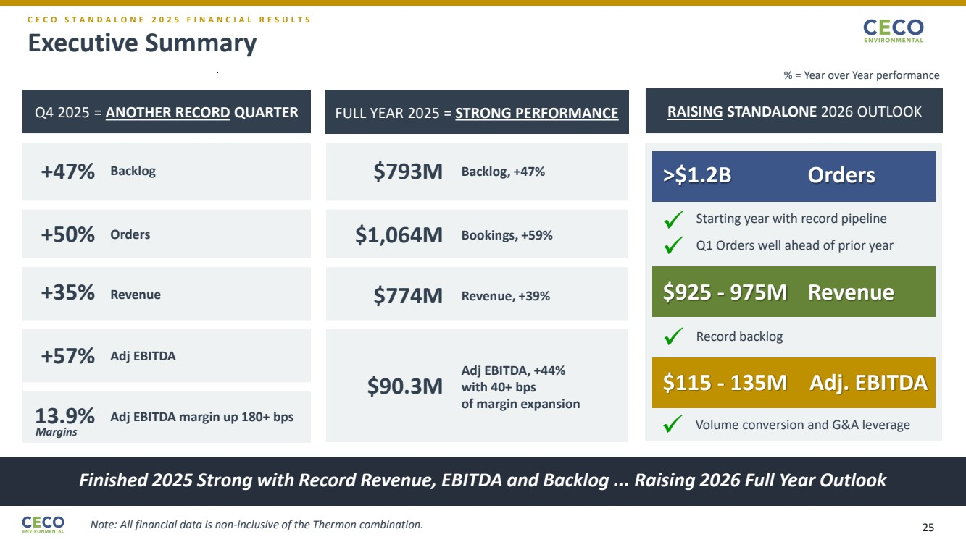 | Executive Summary Finished 2025 Strong with Record Revenue, EBITDA and Backlog ... Raising 2026 Full Year Outlook C E C O S T A N D A L O N E 2 0 2 5 F I N A N C I A L R E S U L T S Q4 2025 = ANOTHER RECORD QUARTER +47% Backlog +50% Orders +35% Revenue +57% Adj EBITDA 13.9% Adj EBITDA margin up 180+ bps FULL YEAR 2025 = STRONG PERFORMANCE RAISING STANDALONE 2026 OUTLOOK >$1.2B Orders $925 - 975M Revenue $115 - 135M Adj. EBITDA Record backlog Starting year with record pipeline Volume conversion and G&A leverage ✓ ✓ $793M Backlog, +47% $1,064M Bookings, +59% $774M Revenue, +39% $90.3M Adj EBITDA, +44% with 40+ bps of margin expansion ✓ Q1 Orders well ahead of prior year ✓ % = Year over Year performance Margins Note: All financial data is non-inclusive of the Thermon combination. 25
 | 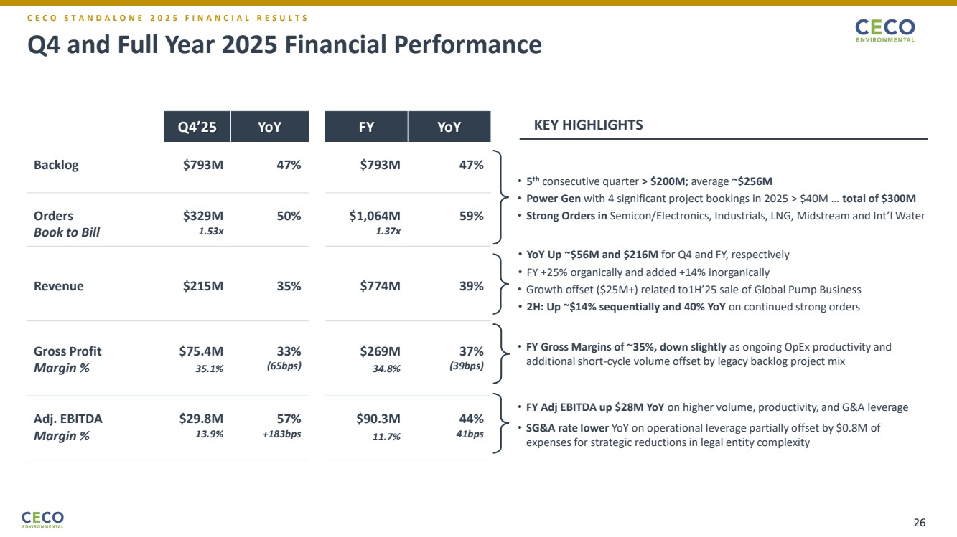 | Q4 and Full Year 2025 Financial Performance Q4’25 YoY FY YoY Backlog $793M 47% $793M 47% Orders Book to Bill $329M 1.53x 50% $1,064M 1.37x 59% Revenue $215M 35% $774M 39% Gross Profit Margin % $75.4M 35.1% 33% (65bps) $269M 34.8% 37% (39bps) Adj. EBITDA Margin % $29.8M 13.9% 57% +183bps $90.3M 11.7% 44% 41bps • 5 th consecutive quarter > $200M; average ~$256M • Power Gen with 4 significant project bookings in 2025 > $40M … total of $300M • Strong Orders in Semicon/Electronics, Industrials, LNG, Midstream and Int’l Water • FY Gross Margins of ~35%, down slightly as ongoing OpEx productivity and additional short-cycle volume offset by legacy backlog project mix • YoY Up ~$56M and $216M for Q4 and FY, respectively • FY +25% organically and added +14% inorganically • Growth offset ($25M+) related to1H’25 sale of Global Pump Business • 2H: Up ~$14% sequentially and 40% YoY on continued strong orders • FY Adj EBITDA up $28M YoY on higher volume, productivity, and G&A leverage • SG&A rate lower YoY on operational leverage partially offset by $0.8M of expenses for strategic reductions in legal entity complexity KEY HIGHLIGHTS C E C O S T A N D A L O N E 2 0 2 5 F I N A N C I A L R E S U L T S 26
 | 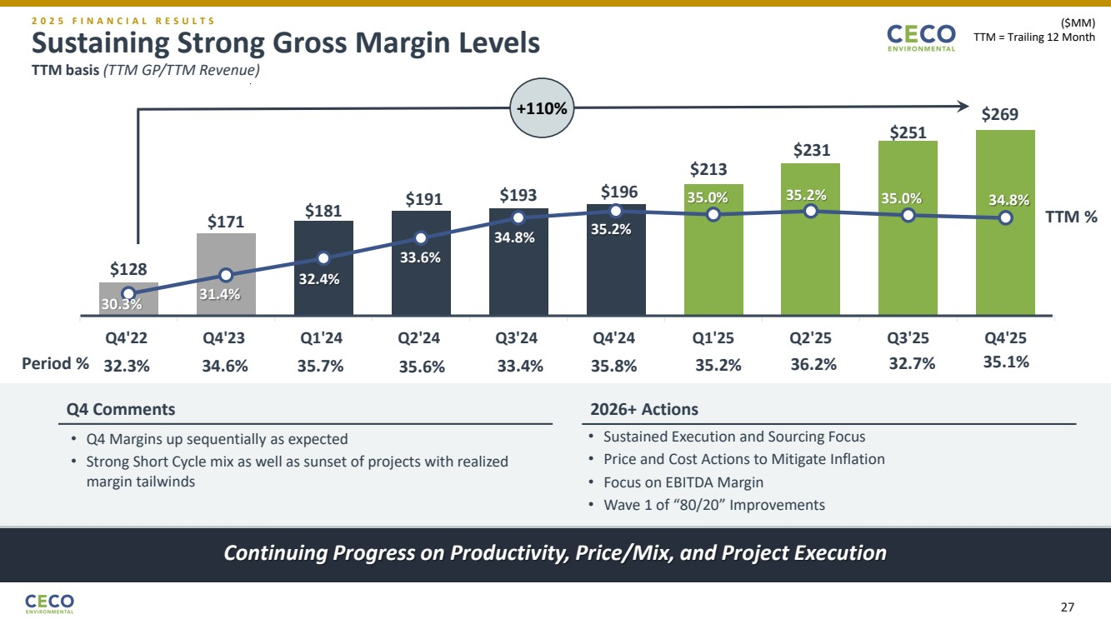 | Sustaining Strong Gross Margin Levels TTM basis (TTM GP/TTM Revenue) Continuing Progress on Productivity, Price/Mix, and Project Execution 2 0 2 5 F I N A N C I A L R E S U L T S $128 $171 $181 $191 $193 $196 $213 $231 $251 30.3% 31.4% 32.4% 33.6% 34.8% 35.2% 35.0% 35.2% 35.0% 34.8% 29. 0% 31. 0% 33. 0% 35. 0% 37. 0% 39. 0% 100 .0 120 .0 140 .0 160 .0 180 .0 200 .0 220 .0 240 .0 260 .0 Q4'22 Q4'23 Q1'24 Q2'24 Q3'24 Q4'24 Q1'25 Q2'25 Q3'25 Q4'25 ($MM) TTM = Trailing 12 Month • Q4 Margins up sequentially as expected • Strong Short Cycle mix as well as sunset of projects with realized margin tailwinds • Sustained Execution and Sourcing Focus • Price and Cost Actions to Mitigate Inflation • Focus on EBITDA Margin • Wave 1 of “80/20” Improvements $269 Period % 32.3% 34.6% 35.7% 35.6% 33.4% 35.8% 35.2% 36.2% 32.7% 35.1% +110% Q4 Comments 2026+ Actions TTM % 27
 | 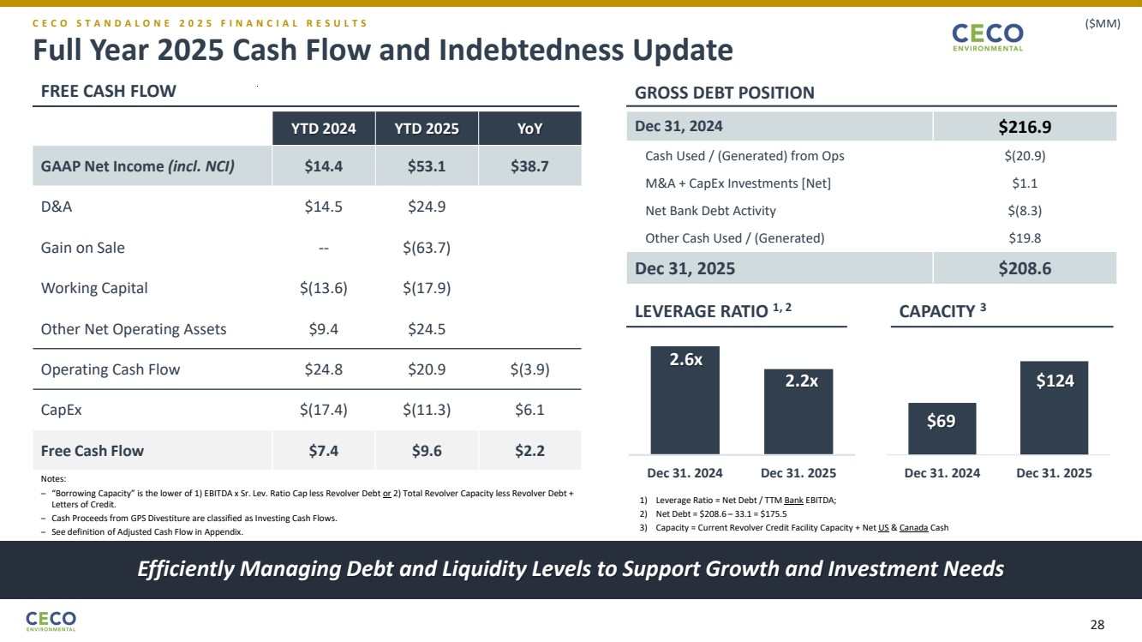 | Full Year 2025 Cash Flow and Indebtedness Update Efficiently Managing Debt and Liquidity Levels to Support Growth and Investment Needs C E C O S T A N D A L O N E 2 0 2 5 F I N A N C I A L R E S U L T S ($MM) YTD 2024 YTD 2025 YoY GAAP Net Income (incl. NCI) $14.4 $53.1 $38.7 D&A $14.5 $24.9 Gain on Sale -- $(63.7) Working Capital $(13.6) $(17.9) Other Net Operating Assets $9.4 $24.5 Operating Cash Flow $24.8 $20.9 $(3.9) CapEx $(17.4) $(11.3) $6.1 Free Cash Flow $7.4 $9.6 $2.2 Dec 31, 2024 $216.9 Cash Used / (Generated) from Ops $(20.9) M&A + CapEx Investments [Net] $1.1 Net Bank Debt Activity $(8.3) Other Cash Used / (Generated) $19.8 Dec 31, 2025 $208.6 Notes: ‒ “Borrowing Capacity” is the lower of 1) EBITDA x Sr. Lev. Ratio Cap less Revolver Debt or 2) Total Revolver Capacity less Revolver Debt + Letters of Credit. ‒ Cash Proceeds from GPS Divestiture are classified as Investing Cash Flows. ‒ See definition of Adjusted Cash Flow in Appendix. 2.6x 2.2x Dec 31. 2024 Dec 31. 2025 $69 $124 Dec 31. 2024 Dec 31. 2025 1) Leverage Ratio = Net Debt / TTM Bank EBITDA; 2) Net Debt = $208.6 – 33.1 = $175.5 3) Capacity = Current Revolver Credit Facility Capacity + Net US & Canada Cash FREE CASH FLOW GROSS DEBT POSITION LEVERAGE RATIO 1, 2 CAPACITY 3 28
 | 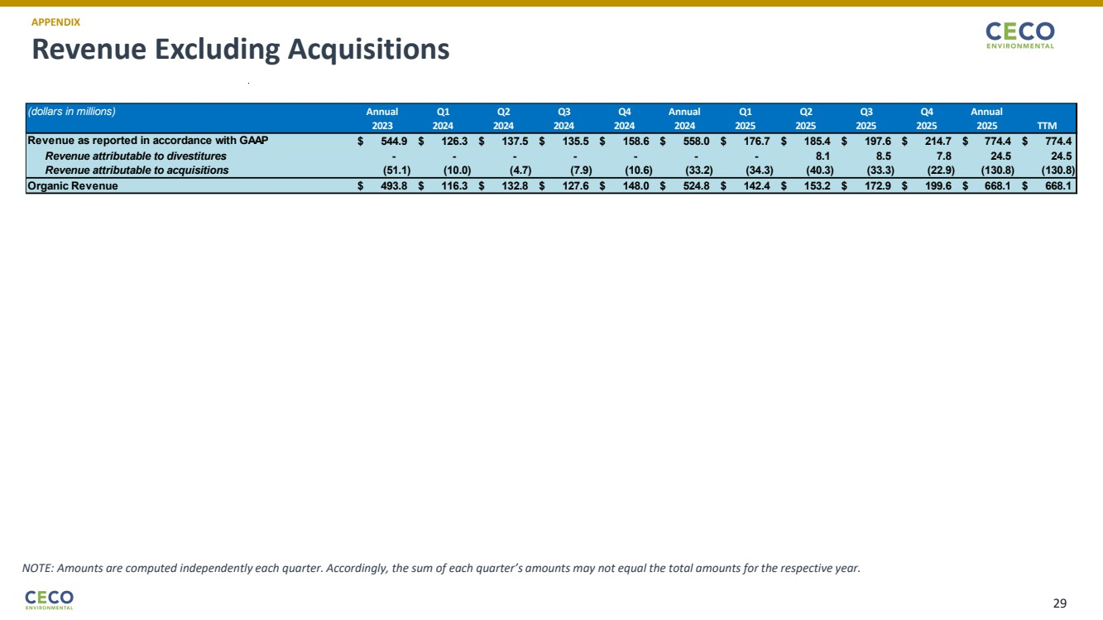 | Revenue Excluding Acquisitions APPENDIX NOTE: Amounts are computed independently each quarter. Accordingly, the sum of each quarter’s amounts may not equal the total amounts for the respective year. (dollars in millions) Annual Q1 Q2 Q3 Q4 Annual Q1 Q2 Q3 Q4 Annual 2023 2024 2024 2024 2024 2024 2025 2025 2025 2025 2025 TTM $ 544.9 $ 126.3 $ 137.5 $ 135.5 $ 158.6 $ 558.0 $ 176.7 $ 185.4 $ 197.6 $ 214.7 $ 774.4 $ 774.4 - - - - - - - 8.1 8.5 7.8 24.5 24.5 (51.1) (10.0) (4.7) (7.9) (10.6) (33.2) (34.3) (40.3) (33.3) (22.9) (130.8) (130.8) Organic Revenue $ 493.8 $ 116.3 $ 132.8 $ 127.6 $ 148.0 $ 524.8 $ 142.4 $ 153.2 $ 172.9 $ 199.6 $ 668.1 $ 668.1 Revenue as reported in accordance with GAAP Revenue attributable to divestitures Revenue attributable to acquisitions 29
 | 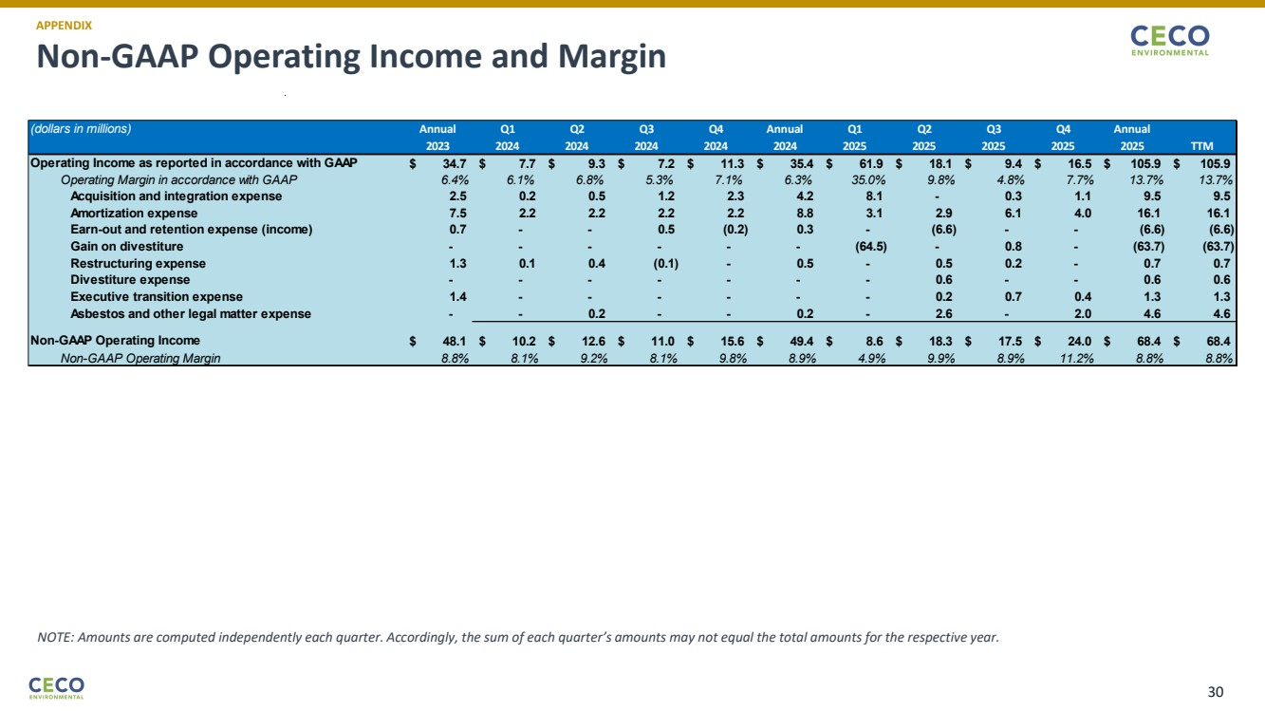 | Non-GAAP Operating Income and Margin APPENDIX NOTE: Amounts are computed independently each quarter. Accordingly, the sum of each quarter’s amounts may not equal the total amounts for the respective year. (dollars in millions) Annual Q1 Q2 Q3 Q4 Annual Q1 Q2 Q3 Q4 Annual 2023 2024 2024 2024 2024 2024 2025 2025 2025 2025 2025 TTM $ 34.7 $ 7.7 $ 9.3 $ 7.2 $ 11.3 $ 35.4 $ 61.9 $ 18.1 $ 9.4 $ 16.5 $ 105.9 $ 105.9 Operating Margin in accordance with GAAP 6.4% 6.1% 6.8% 5.3% 7.1% 6.3% 35.0% 9.8% 4.8% 7.7% 13.7% 13.7% Acquisition and integration expense 2.5 0.2 0.5 1.2 2.3 4.2 8.1 - 0.3 1.1 9.5 9.5 Amortization expense 7.5 2.2 2.2 2.2 2.2 8.8 3.1 2.9 6.1 4.0 16.1 16.1 Earn-out and retention expense (income) 0.7 - - 0.5 (0.2) 0.3 - (6.6) - - (6.6) (6.6) Gain on divestiture - - - - - - (64.5) - 0.8 - (63.7) (63.7) Restructuring expense 1.3 0.1 0.4 (0.1) - 0.5 - 0.5 0.2 - 0.7 0.7 Divestiture expense - - - - - - - 0.6 - - 0.6 0.6 Executive transition expense 1.4 - - - - - - 0.2 0.7 0.4 1.3 1.3 Asbestos and other legal matter expense - - 0.2 - - 0.2 - 2.6 - 2.0 4.6 4.6 $ 48.1 $ 10.2 $ 12.6 $ 11.0 $ 15.6 $ 49.4 $ 8.6 $ 18.3 $ 17.5 $ 24.0 $ 68.4 $ 68.4 Non-GAAP Operating Margin 8.8% 8.1% 9.2% 8.1% 9.8% 8.9% 4.9% 9.9% 8.9% 11.2% 8.8% 8.8% Operating Income as reported in accordance with GAAP Non-GAAP Operating Income 30
 | 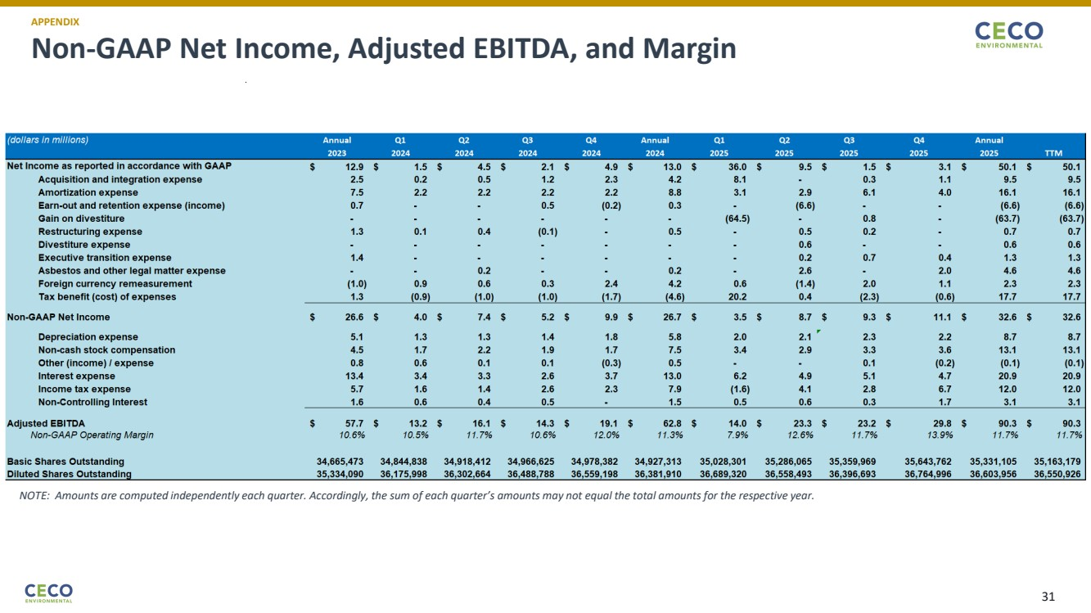 | Non-GAAP Net Income, Adjusted EBITDA, and Margin APPENDIX NOTE: Amounts are computed independently each quarter. Accordingly, the sum of each quarter’s amounts may not equal the total amounts for the respective year. 2) 2) 3) 4) 31
 | 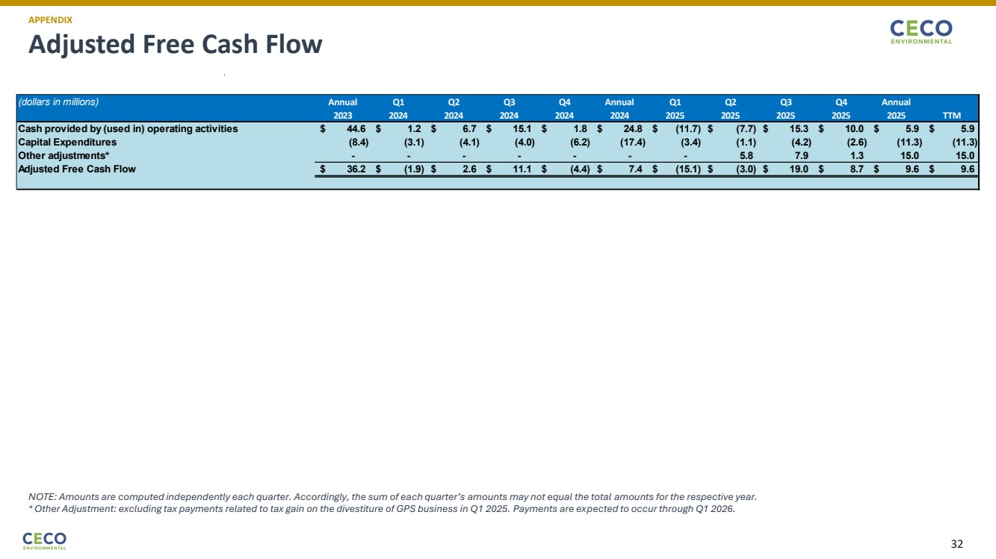 | Adjusted Free Cash Flow APPENDIX NOTE: Amounts are computed independently each quarter. Accordingly, the sum of each quarter’s amounts may not equal the total amounts for the respective year. * Other Adjustment: excluding tax payments related to tax gain on the divestiture of GPS business in Q1 2025. Payments are expected to occur through Q1 2026. (dollars in millions) Annual Q1 Q2 Q3 Q4 Annual Q1 Q2 Q3 Q4 Annual 2023 2024 2024 2024 2024 2024 2025 2025 2025 2025 2025 TTM Cash provided by (used in) operating activities $ 44.6 $ 1.2 $ 6.7 $ 15.1 $ 1.8 $ 24.8 $ (11.7) $ (7.7) $ 15.3 $ 10.0 $ 5.9 $ 5.9 Capital Expenditures (8.4) (3.1) (4.1) (4.0) (6.2) (17.4) (3.4) (1.1) (4.2) (2.6) (11.3) (11.3) Other adjustments* - - - - - - - 5.8 7.9 1.3 15.0 15.0 Adjusted Free Cash Flow $ 36.2 $ (1.9) $ 2.6 $ 11.1 $ (4.4) $ 7.4 $ (15.1) $ (3.0) $ 19.0 $ 8.7 $ 9.6 $ 9.6 32

