Filed by CECO Environmental Corp.
Pursuant to Rule 425 under the Securities Act of 1933 and
deemed filed pursuant to Rule 14a-12 of the Securities Exchange Act of 1934
Subject Company: Met-Pro Corporation
Commission File No. 001-07763

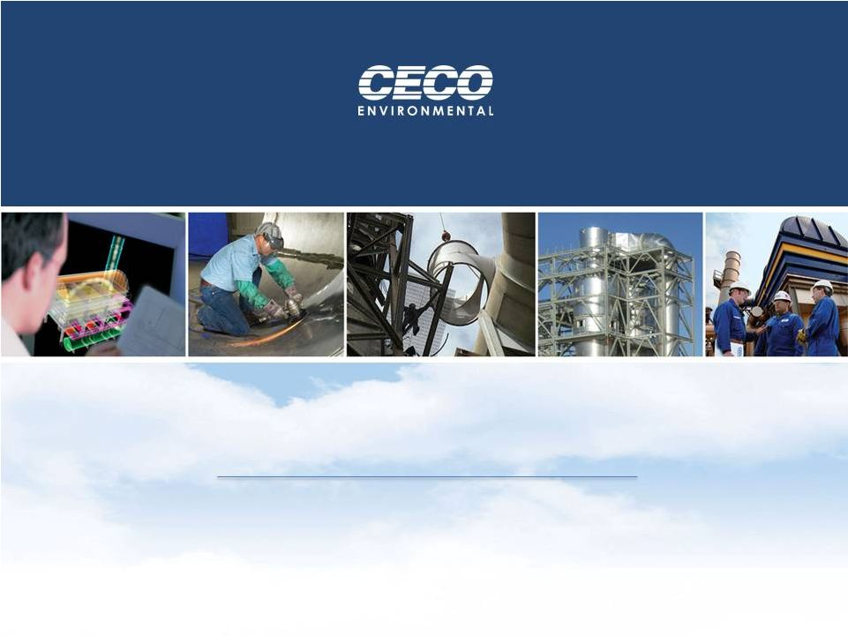
Integrated Clean Air Solutions for Industry
CECO and Met-Pro
Combining Forces for a Stronger Tomorrow
April 22, 2013

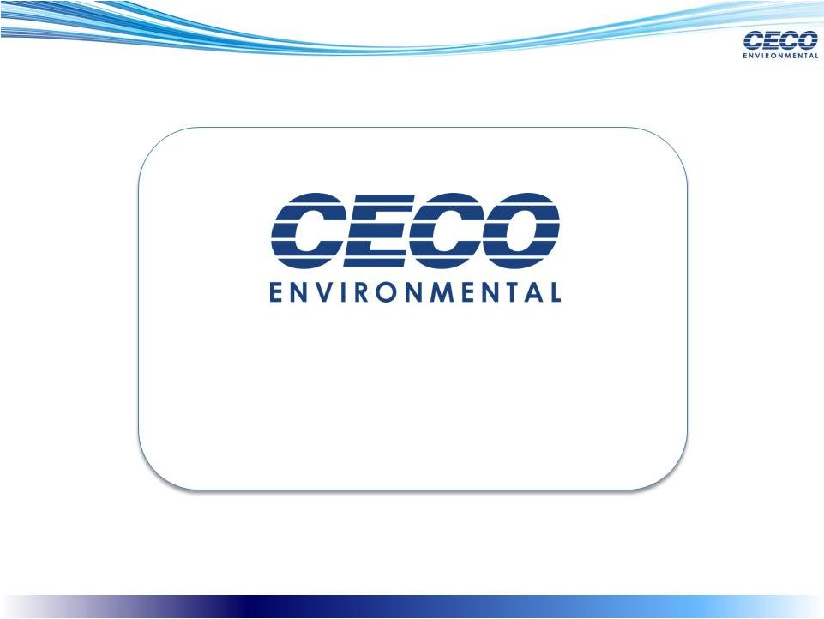
2
Jeff Lang
Chief Executive Officer & Director


3
Forward Looking Statements
Information in this document contains forward-looking statements, which involve a number of risks and uncertainties. CECO Environmental Corp. (CECO) and
Met-Pro Corporation (Met-Pro) caution readers that any forward-looking information is not a guarantee of future performance and that actual results could differ
materially from those contained in the forward-looking information. All such forward-looking statements include, but are not limited to, statements about the
benefits of the business combination transaction involving CECO and Met-Pro, including future financial and operating results, the new companys plans,
objectives, expectations and intentions and other statements that are not historical facts.
The following factors, among others, could cause actual results to differ from those set forth in the forward-looking statements: the failure of CECO or Met-Pro
stockholders to approve the transaction; the risk that the businesses will not be integrated successfully; the risk that the cost savings and any other synergies from
the transaction may not be fully realized or may take longer to realize than expected; disruption from the transaction making it more difficult to maintain
relationships with customers, employees or suppliers; competition and its effect on pricing, spending, third-party relationships and revenues. Additional factors that
may affect future results are contained in CECOs and Met-Pros filings with the SEC. CECO and Met-Pro disclaim any obligation to update and revise statements
contained in these materials based on new information or otherwise.
Important Information for Investors and Stockholders

This communication does not constitute an offer to sell or the solicitation of an offer to buy securities or a solicitation of any vote or approval. This communication
is not a substitute for the prospectus/proxy statement CECO Environmental Corp. and Met-Pro Corporation will file with the SEC. Investors in CECO or Met-Pro
are urged to read the prospectus/proxy statement, which will contain important information, including detailed risk factors, when it becomes available.
The prospectus/proxy statement and other documents that will be filed by the Company and Met-Pro with the SEC will be available free of charge at the SECs
website, www.sec.gov, or by directing a request when such a filing is made to CECO Environmental Corp., 4625 Red Bank Road, Suite 200, Cincinnati, Ohio
45227, Attention: Investor Relations; or to Met-Pro Corporation, 160 Cassell Road, Harleysville, Pennsylvania 19438, Attention: Investor Relations. A final
prospectus/proxy statement will be mailed to CECOs stockholders and shareholders of Met-Pro.

Non-GAAP
These slides may contain non-GAAP financial measures. For purposes of Regulation G, a non-GAAP financial measure is a numerical measure of historical or
future financial performance that excludes amounts that are included in the most directly comparable measure calculated and presented in accordance with GAAP
in the statement of income, balance sheet or statement of cash flows (or equivalent statements). In accordance with the requirements of Regulation G, the table in
the Appendix presents the most directly comparable GAAP financial measure and reconciles non-GAAP adjusted EBITDA to the comparable GAAP measure.
Adjusted EBITDA is not calculated in accordance with GAAP, and should be considered supplemental to, and not as a substitute for, or superior to, financial
measures calculated in accordance with GAAP.
Proxy Solicitation
CECO and Met-Pro, and certain of their respective directors, executive officers and other members of management and employees may be deemed participants in
the solicitation of proxies in connection with the proposed transactions. Information about the directors and executive officers of CECO is set forth in the proxy
statement for CECOs 2013 annual meeting of stockholders and CECOs 10-K for the year ended December 31, 2012. Information about the directors and
executive officers of Met-Pro is set forth in the proxy statement for Met-Pros 2012 annual meeting of shareholders and Met-Pros Form 10-K for the year ended
January 31, 2012. Investors may obtain additional information regarding the interests of such participants in the proposed transactions by reading the
prospectus/proxy statement for such proposed transactions when it becomes available.

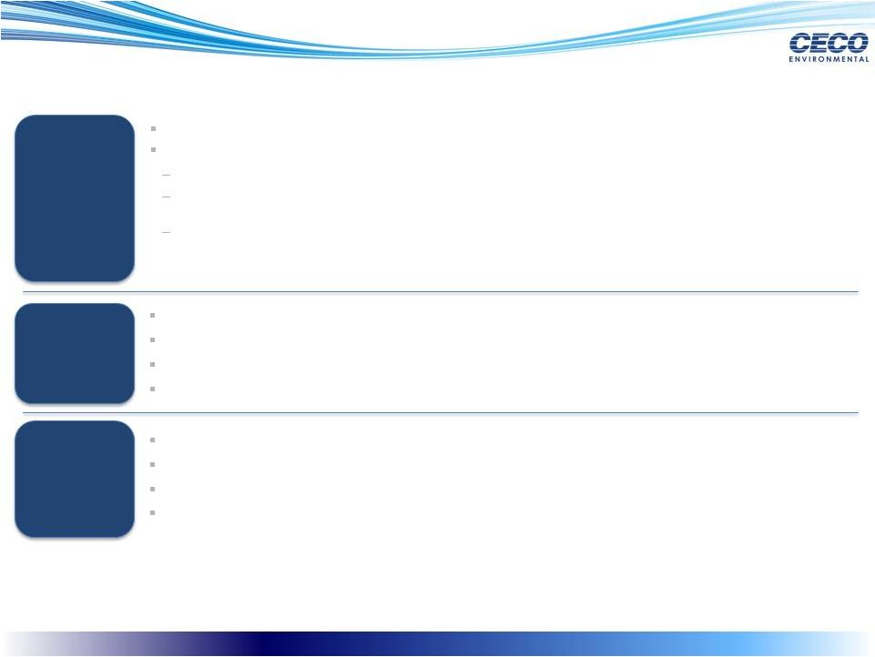
Transaction Summary
4
Structure &
Consideration
Structure &
Consideration
(1)
(2)
Financial
Benefits
Financial
Benefits
Expect ~$9 million in annual cost synergies with full realization by CY2014
Strong margin uplift
Improved free cash flow performance
Highly accretive to EPS
Conditions &
Expected
Closing
Conditions &
Expected
Closing
Shareholder approval from both parties
NASDAQ approval
Other customary approvals and closing conditions
Expected close: September 2013
CECO has agreed to acquire Met-Pro for $13.75 per share in cash and/or CECO common stock
Stock
consideration:
$6.50
per
share
($97.1
million,
representing
~31%
ownership
in
pro
forma
entity)
(1)
Cash / Stock election: Met-Pro shareholders have the right to elect consideration in varying amounts of cash
or stock, subject to proration mechanism
Collar:
stock
consideration
exchange
ratio
equals
$13.75
per
share
divided
by
the
Parent
Trading
Price
(2)
,
provided that if the result of such calculation is less than or equal to 1.000x, the exchange ratio shall be 1.000x,
and if the result of such calculation is greater than or equal to 1.352x, the exchange ratio shall be 1.352x.
15 day volume-weighted average closing price was $11.96 as of April 19, 2013. Stock consideration subject to floating exchange ratio and collar mechanism.
Parent Trading Price means the volume weighted average price of CECO common stock, as reported on the Nasdaq Global Market for the fifteen (15) consecutive trading days ending on the trading day immediately preceding the closing date.
Cash
consideration:
$7.25
per
share
($110.2
million)
(1)

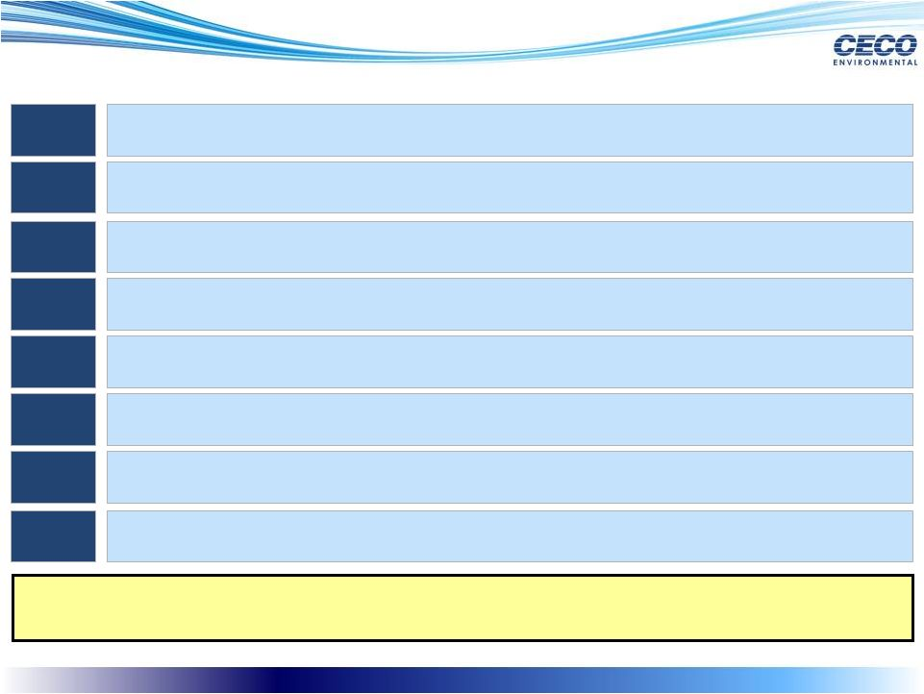
Key Transaction Benefits
Combination Creates a New Class of Air Pollution Control Assets Poised to
Achieve Superior Growth
5
Strong strategic fit
Opportunity to consolidate highly fragmented market and become clear
independent market leader
Expanded global reach
1.
2.
3.
4.
5.
6.
Attractive market growth drivers underpin strong growth potential
7.
Experienced management with proven track records as public companies
8.
Poised to benefit from enhanced end-market and customer diversity
Highly financially compelling with enhanced scale
Poised to achieve significant synergies

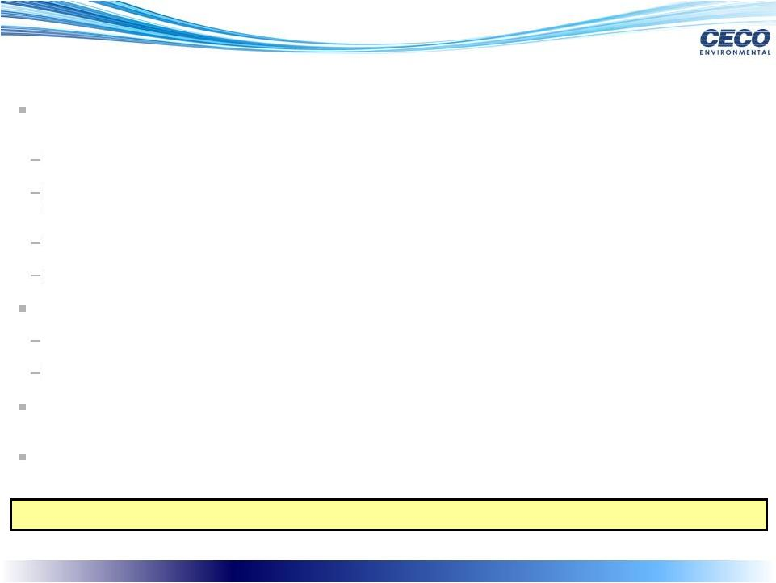
Significant Benefits to CECO Shareholders
6
Significant majority ownership of the highly attractive CECO / Met-Pro combined
company
Stronger, more attractive industry competitor than CECO on standalone basis
Forms a premier global leader in air pollution control, fluid handling, filtration & equipment
solutions
Greater ability to penetrate higher growth geographies and end-markets
Benefit from increased scale and improved market liquidity
Participation in considerable value creation resulting from the combination
~69%
(1)
ownership of pro forma Company for CECO shareholders
Expect to realize ~$9 million in annual cost synergies
Combination with a highly complementary strategic partner with proven track record as
a public company
Benefit from increased size, diversification
Combination Significantly More Compelling than Standalone
(1)
Based on 15 day volume-weighted average closing price of $11.96 as of April 19, 2013. Stock consideration subject to floating exchange ratio and collar mechanism.

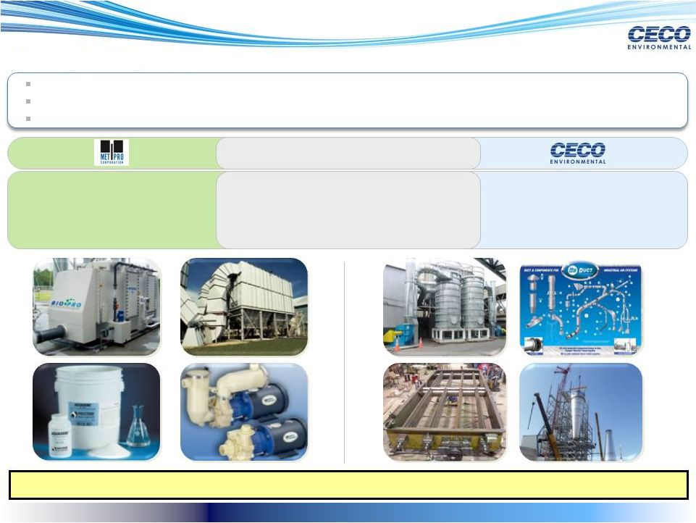
Strong Strategic Fit
7
Filtration
Core Overlapping Competencies
Ventilation Systems
Catalytic Reduction
Equipment, Components, Parts
Filtration and purification equipment
Fluid handling equipment
Proprietary chemicals
Air pollution control equipment &
technology
Related parts and services for
industrial air systems
Ability to leverage unique trade knowledge, patents and manufacturing capabilities
Introduction of pumps business enhances margin profile while diversifying end-market exposure
Opportunity to Capitalize on Core Business Alignment
Strong complementary product portfolio creates one-stop-shop to best serve customers

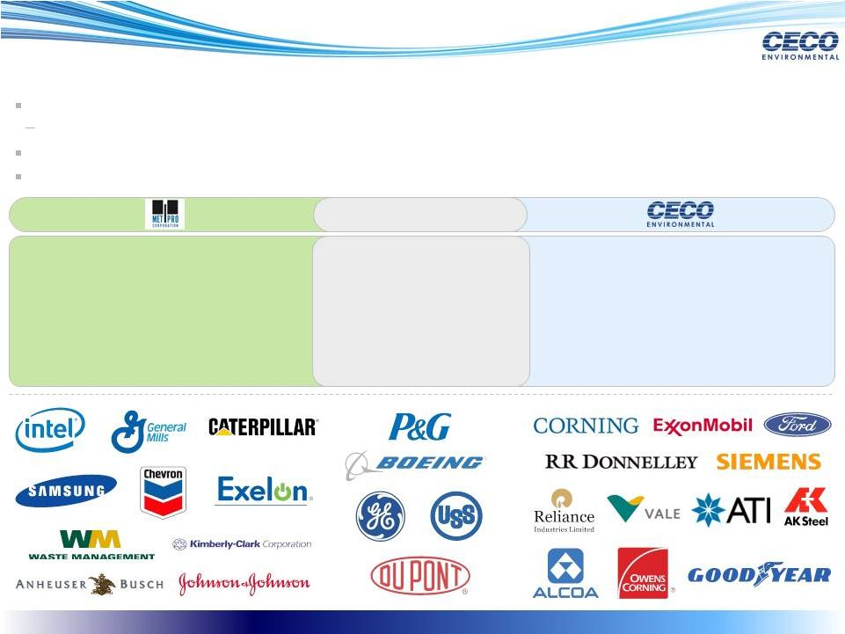
Poised to Benefit from Enhanced End-Market and Customer Diversity
8
Combination enhances breadth and depth of end-market exposure to blue-chip customer base
Expansion results in natural hedge against market and customer-specific volatility
Unlocks significant cross-selling opportunities with access to over 11,500 active customers worldwide
Strong play to consolidate market and benefit from economies of scale and scope
Core Competencies
Pharmaceutical
Automotive
Chemical / Petro
Steel & Metal
Refinery
Industrial Manufacturing
Food Processing
Saltwater
Aquariums
Semiconductor /
Electronics
Municipalities
Universities
Hospitals
Government
Facilities
Industrial Ventilation
Traditional Power & Natural Gas
Power
Aerospace

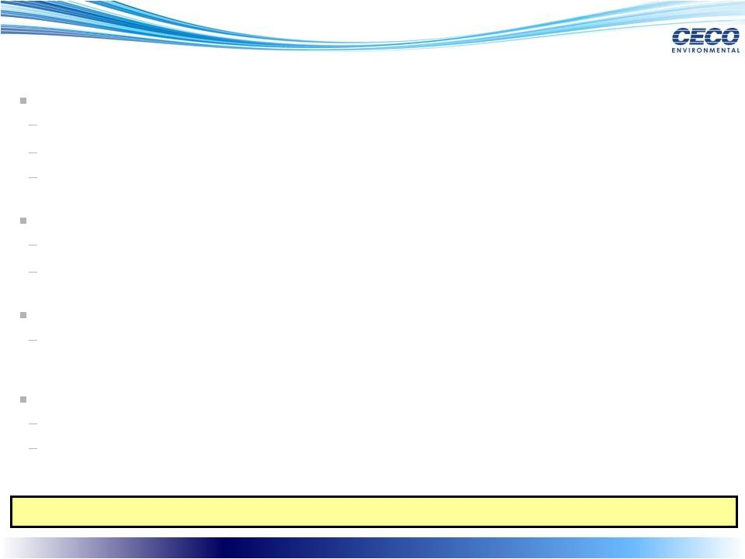
Attractive Market Growth Drivers
9
Favorable Industry Dynamics Underpin Strong Growth Potential
Increasingly stringent air pollution control regulatory environment
U.S. EPA: Mandated air quality standards for power plants
OSHA: Established permissible exposure limits for contaminants
U.S. DOE: Promoting new technology growth in biomass and gasification
Shale revolution driving natural gas power generation
Consumption of natural gas expected to grow ~45% by 2035
Natural gas is expected to displace coal-fired plants
Chinas rapid industrialization and focus on compliance
12th 5-Year Plan: All coal/oil fired thermal units must comply with significantly stricter air
pollution controls by January 1, 2014
Increased demand from refining and chemical processes
North American shale gas feedstock fundamentals drive manufacturing advantage
Re-industrialization
of North America: Many new industrial/manufacturing projects slated for
startup

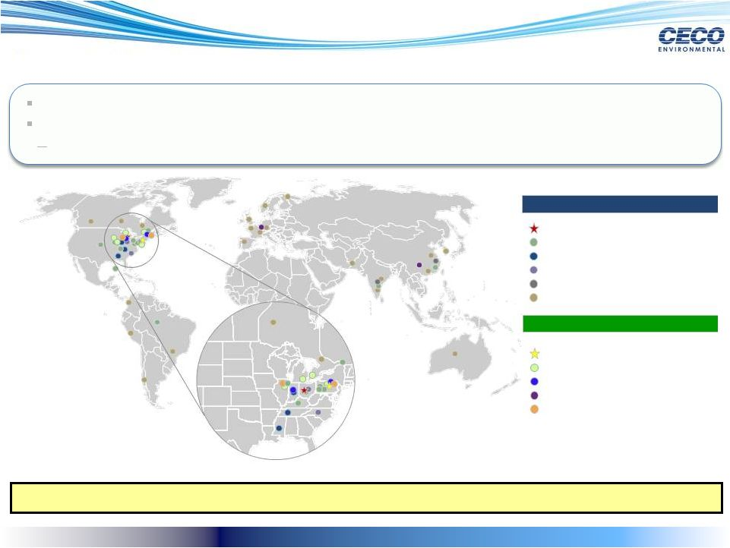
Expanded Global Reach
10
Strengthened Geographic Footprint with Deep Emerging Market Exposure
Pro
forma
company
will
have
a
well-balanced
geographic
portfolio
of
assets
Combined
platform
enhances
ability
to
capitalize
on
emerging
market
growth
Well-established
presence
in
China,
India
and
Latin
America
Component Parts Facilities
Future Facilities
Agents
Contracting / Services Facilities
Engineered Equipment Facilities
CECO Headquarters
Mefiag Filtration Technologies
Filtration / Purification Technologies
Fluid Handling Technologies
Product Recovery/Pollution Control Technologies
Met-Pro Headquarters
CECO
Met-Pro

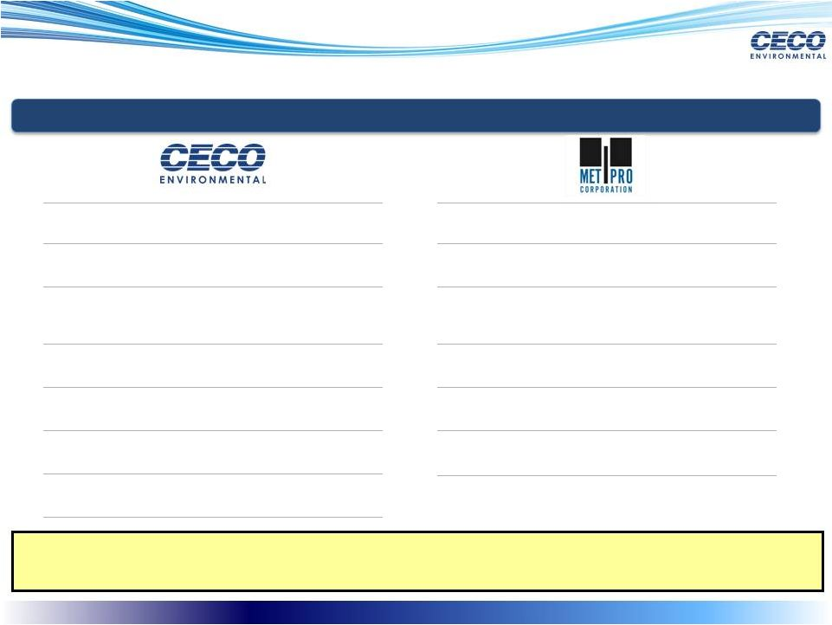
Experienced Management Teams with Proven Track Records of Success
11
Opportunity to Leverage the Strength of Two World-Class Management Teams
with Deep Industry, Operational and Technical Expertise
Key Management
Key Management
Jeff Lang
Benton Cook, CPA
Roland Bollman
Bruce Brashear
Jack Neiser
Bill Frank
Hilliary Jeffries
Raymond J. De Hont
Neal E. Murphy
Gennaro A. DAlterio
Gregory C. Kimmer
Paul A. Tetley
Hans J.D. Huizinga
Chief Executive Officer and Director
Interim Chief Financial Officer, Corporate Controller
Executive Vice President, Services, Parts and Filters
Vice President, FKI-Buell
President, EFFOX Global
President, Adwest, CECO Abatement and Busch International
Vice President, HR & Administration
Chief Executive Officer and President
VP-Finance, Chief Financial Officer, Secretary and Treasurer
VP/GM Met-Pro Global Pump Solutions and Keystone Filters
VP.GM Met-Pro Environmental Air Solutions
VP/GM Strobic Air Corporation
Managing Director Mefiag BV and GZ Filter Systems and GM Mefiag
USA

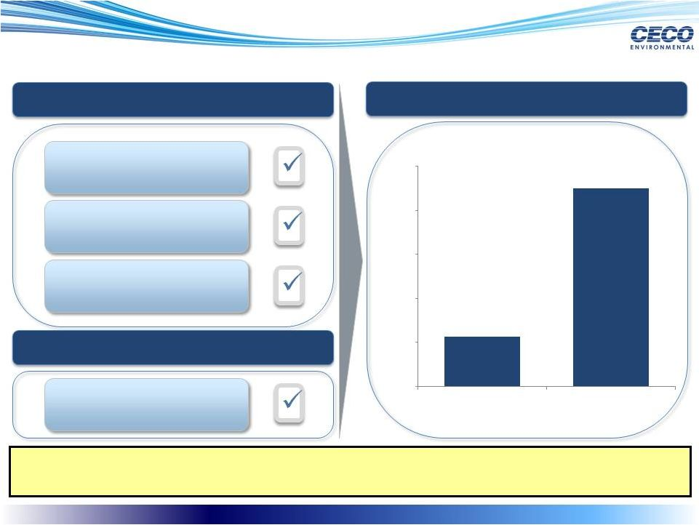
Combination has Potential to Achieve Significant Synergies
Expected Annual Cost Synergies of ~$9 million by 2014
Significant Implied Liquidity Through Monetization of Real Estate
12
CECO / Met-Pro Cost Synergies
CECO / Met-Pro Cost Synergies
Operational Synergies
Manufacturing / Fabrication
Optimization
Value Creation
Value Creation
Cash Flow Synergies
Cash Flow Synergies
Monetization of Real Estate
Assets
Integration Efficiencies
~$2.3
~$9.0
$-
$2.0
$4.0
$6.0
$8.0
$10.0
2013E
2014E
Estimated Expected Synergies

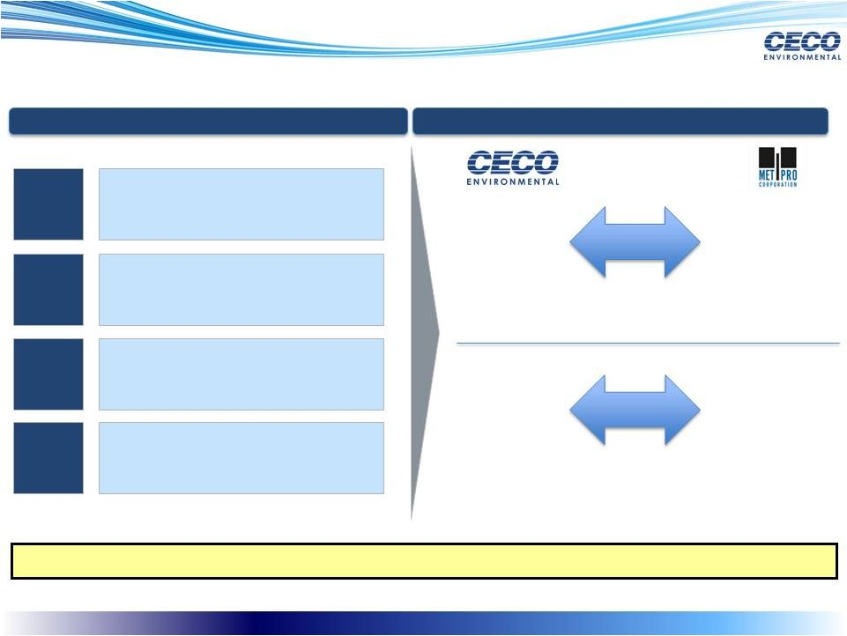
Additional Potential Sources of Synergies
Further Upside Potential from Revenue Synergies
13
Potential Revenue Synergies
Potential Revenue Synergies
Abatement
Systems
Cross-Selling Opportunities
Cross-Selling Opportunities

Small, medium
and large RTOs

Some abatement
systems need
pre-filters

Engineering
Installations

MPEAS
manufactures
TOs, catalytic
oxidizers and has
a concentrator

MPEAS / Bio-
Reaction

Clamp together
duct components
for any (lab)
hoods and the
plenums

Duall Scrubbers

Strobic Air

Steel flanges,
expansion joints
Increased customer
penetration
Greater emerging market
presence
Benefits from scale &
technology platforms
1.
2.
3.
4.
Leverage service footprint to
grow aftermarket & recurring
revenue
Service &
Parts

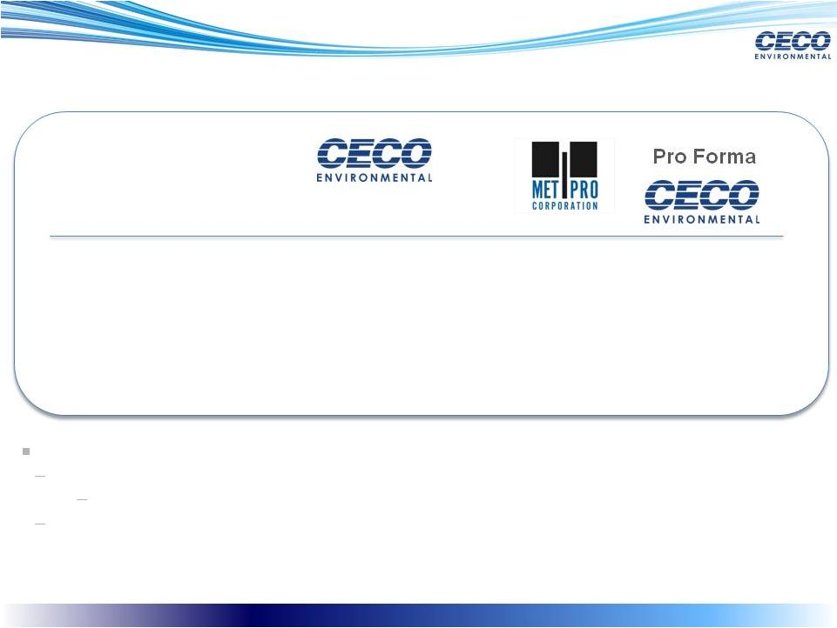
Highly Financially Compelling with Enhanced Scale
14
(1)
Pro forma for the full year impact of the Adwest and Aarding acquisitions, representing $41.5 million of Sales.
(2)
Pro forma for the full year impact of the Adwest and Aarding acquisitions, representing $6.1 million of EBITDA.
(3)
Based
on
LTM
12/31/2012
combined
EBITDA
of
$40.4
million,
which
includes
full
year
impact
of
the
Adwest
and
Aarding
acquisitions,
representing
$6.1
million
of
EBITDA.
Includes
$2.25
million
in
pro
forma
synergies.
Total
pro
forma
debt
of
approximately
$95
million
at
rates
of
approximately
LIBOR
plus
175

200
bps.
($ Millions)
PF Leverage (w/ Syn.)
(1/31/2013)
(12/31/2012)
Standalone
CECO Plus
Aarding / Adwest
LTM Margin (%)
LTM Adj. EBITDA
LTM Sales
13.7%
$18.5
$135.1
14.3%
$15.8
$109.9
2.2x
(3)
14.1%
$40.4
(2)
$286.5
(1)
13.9%
$24.6
(2)
$176.6
(1)
Highly Favorable Financing Terms
Low leverage profile supported by strong cash flow to effectively service debt
Total
new
debt
of
approximately
$95
million
at
rates
of
LIBOR
plus
175
-
200
Strong revolver flexibility with $60 million total capacity


In Summary
15
Two Industry Leaders
Strong alignment with mega trends
Positive outlook for 2013 and beyond for both companies
Combined Strengths = Unique Value Creation Potential
Sector leaders serving high growth, attractive markets
Leading company with strong air pollution control, fluid handling and filtration platforms
Expected highly accretive to earnings and future growth
Day one winning combination for CECO and Met-Pro shareholders
Substantial cost and revenue synergies as well as and long-term value creation
opportunities
Strong balance sheet and cash flow to support growth and cash returned to
shareholders


Appendix
16

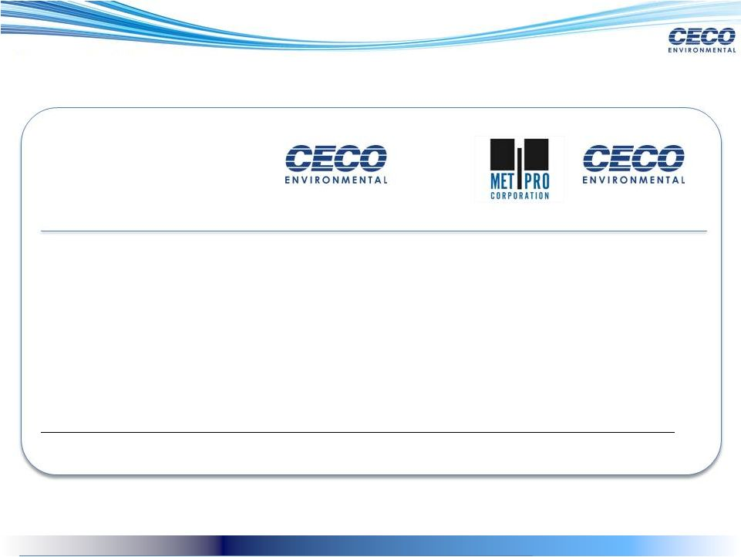
Reconciliation of Adjusted EBITDA
17
(12/31/2012)
Standalone
CECO Plus
Aarding / Adwest
(1)
Pro Forma
(1)
(1)
Pro forma for the full year impact of the Adwest and Aarding acquisitions.
Sales
$ 135.1
$ 176.6
109.9
$
286.5
$
Net Income
10.9
$
14.3
$
8.0
$
22.3
$
Income Tax (Benefit)
4.5
6.1
3.8
9.9
Interest Expense
1.2
1.2
0.2
1.4
D&A
1.2
1.8
2.0
3.8
Option Wage Expense
0.7
0.7
0.9
1.6
Other
-
0.6
0.8
1.4
Adjusted EBITDA
18.5
$
24.6
$
15.8
$
40.4
$
(1/31/2013)

