UNITED STATES

SECURITIES AND EXCHANGE COMMISSION
Washington, DC 20549

SCHEDULE 14A

(Rule 14a-101)

Proxy Statement Pursuant To Section 14(a) Of The

Securities Exchange Act Of 1934

Filed by the Registrant ☒ Filed by a party other than the Registrant ☐

Check the appropriate box:

- Preliminary proxy statement

- Confidential, for use of the Commission only (as permitted by Rule 14a-6(e)(2))

- Definitive proxy statement

- Definitive additional materials

- Soliciting material pursuant to Sec. 240.14a-11(c) or Sec. 240.14a-12


CECO ENVIRONMENTAL CORP.

(Name of Registrant as Specified in Its Charter)

(Name of Person(s) Filing Proxy Statement, if other than Registrant)

Payment of filing fee (Check the appropriate box):

- No Fee Required

- Fee paid previously with preliminary materials:

- Fee computed on table in exhibit required by Item 25(b) per Exchange Act Rules 14a-6(i)(1) and 0-11


Your Vote Counts!

CECO ENVIRONMENTAL CORP.

2022 Annual Meeting

Vote by June 07, 2022
11:59 PM ET



CECO ENVIRONMENTAL CORP.
C/O BROADRIDGE
P.O. BOX 1342
BRENTWOOD, NY 11717



You invested in CECO ENVIRONMENTAL CORP. and it’s time to vote!

You have the right to vote on proposals being presented at the Annual Meeting. This is an important notice regarding the availability of proxy material for the stockholder meeting to be held on June 08, 2022.

Get informed before you vote

View the Annual Report to Stockholders, Proxy Statement online OR you can receive a free paper or email copy of the material(s) by requesting prior to May 25, 2022. If you would like to request a copy of the material(s) for this and/or future stockholder meetings, you may (1) visit www.ProxyVote.com, (2) call 1-800-579-1639 or (3) send an email to sendmaterial@proxyvote.com. If sending an email, please include your control number (indicated below) in the subject line. Unless requested, you will not otherwise receive a paper or email copy.
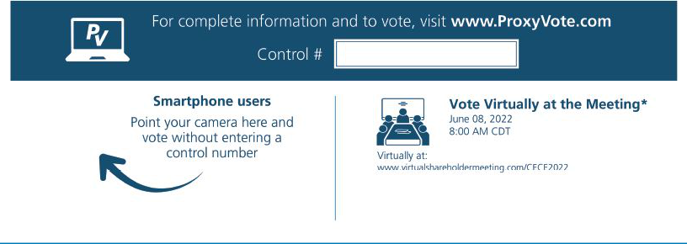

* Please check the meeting materials for any special requirements for meeting attendance.

V1

Vote at www.ProxyVote.com

THIS IS NOT A VOTABLE BALLOT

This is an overview of the proposals being presented at the

upcoming stockholder meeting. Please follow the instructions on

the reverse side to vote these important matters.

Voting Items

Board
Recommends

1. | Election of Directors
 | Nominees:
 | 01) | Jason DeZwirek | 04) | Munish Nanda | 07) Todd Gleason | For
 | 02) | David B. Liner | 05) | Valerie Gentile Sachs
 | 03) | Claudio A. Mannarino | 06) | Richard F. Wallman
2. | To approve, on an advisory basis, the compensation of the Company’s named executive officers. |  |  |  |  | For
3. | To ratify the appointment of BDO USA, LLP as our independent registered public accounting firm for 2022. |  |  |  |  | For
NOTE: To transact such other business as may properly come before the meeting or any adjournments thereof.

Prefer to receive an email instead? While voting on www.ProxyVote.com, be sure to click “Sign up for E-delivery”.

