Filed by CECO Environmental Corp. Pursuant to Rule 425 under the Securities Act of 1933, and deemed filed pursuant to Rule 14a-12 under the Securities Exchange Act of 1934 Subject Company: Thermon Group Holdings, Inc. Commission File No.: 001-35159

CECO-THR Letter to CECO Employees

To: All CECO Employees

Subject: CEO Global Announcement: CECO Combination with Thermon

Dear CECO Associates,

Earlier today, we announced that CECO has entered into a definitive agreement to acquire Thermon, a global leader in industrial process heating and thermal solutions. This is a very exciting moment for CECO. Please take a moment to review the press release which provides additional details about the exciting transaction.

The combination brings together two highly complementary businesses and strengthens our position as a premier engineered solutions provider in the industrial market. Thermon's differentiated thermal capabilities enhance our portfolio and expand our exposure to attractive long-term growth trends, while increasing our scale, diversification and global reach. We share a strong cultural alignment and a commitment to disciplined execution, innovation, and serving customers with excellence. We are dedicated to providing a safe, constructive, and forward-thinking workplace, and to creating long-term opportunities for career growth as part of a larger platform.

It is important to note that nothing changes immediately. Until the transaction closes, CECO and Thermon will continue to operate as separate and independent companies. We remain focused on delivering for our customers and executing our strategy.

We recognize that you may have questions. We will discuss the announcement and the many benefits in more detail at our upcoming all-employee virtual town hall at 7:00 am central time on Thursday, February 26, and we welcome your questions. In addition, employee FAQs are available on myCECO later this morning.

Thank you for your continued dedication and professionalism as we take this next step together. I look forward to welcoming Thermon's businesses, brands and great employees to CECO after the transaction closes.

Sincerely,

Todd Gleason | CEO

CECO Environmental Corp.

No Offer or Solicitation

This communication is for informational purposes only and is not intended to and shall not constitute an offer to buy or sell or the solicitation of an offer to buy or sell any securities, or a solicitation of any vote or approval, nor shall there be any sale of securities in any jurisdiction in which such offer, solicitation or sale would be unlawful prior to registration or qualification under the securities laws of any such jurisdiction. No offering of securities shall be made, except by means of a prospectus meeting the requirements of Section 10 of the Securities Act of 1933, as amended.

Additional Information and Where to Find It

This communication is being made in respect of the proposed merger transaction (the “Proposed Transaction”) involving Thermon Group Holdings, Inc. (“Thermon”) and CECO Environmental Corp. (“CECO”), among other things. The issuance of shares of CECO common stock in connection with the Proposed Transaction will be submitted to the stockholders of CECO for their consideration, and the Proposed Transaction will be submitted to the stockholders of Thermon for their consideration. In connection therewith, CECO intends to file with the SEC a registration statement on Form S-4 (the “Registration Statement”) that will include a joint proxy statement/prospectus. Each of CECO and Thermon may also file other relevant documents with the SEC regarding the Proposed Transaction. This communication is not a substitute for the joint proxy statement/prospectus or registration statement or any other document that CECO or Thermon, as applicable, may file with the SEC in connection with the Proposed Transaction. After the Registration Statement has been declared effective by the SEC, a definitive joint proxy statement/prospectus will be mailed to the stockholders of CECO and Thermon. BEFORE MAKING ANY VOTING OR INVESTMENT DECISION, INVESTORS AND SECURITY HOLDERS OF CECO AND THERMON ARE URGED TO READ THE REGISTRATION STATEMENT, JOINT PROXY STATEMENT/PROSPECTUS AND ANY OTHER RELEVANT DOCUMENTS THAT MAY BE FILED WITH THE SEC, AS WELL AS ANY AMENDMENTS OR SUPPLEMENTS TO THESE DOCUMENTS, CAREFULLY AND IN THEIR ENTIRETY IF AND WHEN THEY BECOME AVAILABLE BECAUSE THEY CONTAIN OR WILL CONTAIN IMPORTANT INFORMATION ABOUT CECO, THERMON, THE PROPOSED TRANSACTION AND RELATED MATTERS. Investors and security holders will be able to obtain free copies of the registration statement and joint proxy statement/prospectus, as well as other filings containing important information about CECO, Thermon and the Proposed Transaction, once such documents are filed with the SEC through the website maintained by the SEC at https://www.sec.gov. Copies of the documents filed with the SEC by CECO will be available free of charge on CECO’s website at https://investors.cecoenviro.com. Copies of the documents filed with the SEC by Thermon will be available free of charge on Thermon’s website at https://ir.thermon.com. The information included on, or accessible through, CECO’s or Thermon’s website is not incorporated by reference into this communication.

Participants in the Solicitation

CECO, Thermon and certain of their respective directors and executive officers may be deemed to be participants in the solicitation of proxies in respect of the Proposed Transaction.

Information about the directors and executive officers of CECO, including a description of their direct or indirect interests, by security holdings or otherwise, is set forth in (i) CECO’s proxy statement for its 2025 Annual Meeting of Stockholders, which was filed with the SEC on April 10, 2025 (and which is available at https://www.sec.gov/ix?doc=/Archives/edgar/data/3197/000155837025004649/ceco-20250520xdef14a.htm), (ii) a Form 8-K filed by CECO on July 24, 2025 (and which is available at https://www.sec.gov/ix?doc=/Archives/edgar/data/0000003197/000095017025098303/ceco-20250718.htm), (iii) a Form 8-K filed by CECO on September 16, 2025 (and which is available at https://www.sec.gov/ix?doc=/Archives/edgar/data/0000003197/000119312525204657/ceco-20250912.htm) and (iv) to the extent holdings of CECO’s securities by the directors or executive officers of CECO have changed since the amounts set forth in CECO’s proxy statement for its 2025 Annual Meeting of Stockholders, such changes have been or will be reflected on Initial Statement of Beneficial Ownership of Securities on Form 3, Statement of Changes in Beneficial Ownership on Form 4, or Annual Statement of Changes in Beneficial Ownership on Form 5 filed with the SEC, which are available at https://www.sec.gov/cgi-bin/own-disp?action=getissuer&CIK=0000003197.

Information about the directors and executive officers of Thermon, including a description of their direct or indirect interests, by security holdings or otherwise, is set forth in (i) Thermon’s proxy statement for its 2025 Annual Meeting of Stockholders, which was filed with the SEC on June 18, 2025 (and which is available at https://www.sec.gov/Archives/edgar/data/1489096/000148909625000097/thr-20250618.htm), (ii) a Form 8-K filed by Thermon on July 1, 2025 (as amended July 15, 2025) (and which is available at https://www.sec.gov/ix?doc=/Archives/edgar/data/0001489096/000148909625000115/thr-20250701.htm) and (iii) to the extent holdings of Thermon’s securities by the directors or executive officers of Thermon’s have changed since the amounts set forth in Thermon’s proxy statement for its 2025 Annual Meeting of Stockholders, such changes have been or will be reflected on Initial Statement of Beneficial Ownership of Securities on Form 3, Statement of Changes in Beneficial Ownership on Form 4, or Annual Statement of Changes in Beneficial Ownership on Form 5 filed with the SEC, which are available at https://www.sec.gov/cgi-bin/own-disp?action=getissuer&CIK=0001489096.

Other information regarding the participants in the proxy solicitations and a description of their direct and indirect interests, by security holdings or otherwise, will be contained in the joint proxy statement/prospectus and other relevant materials to be filed with the SEC regarding the Proposed Transaction when such materials become available. Investors should read the joint proxy statement/prospectus carefully when it becomes available before making any voting or investment decisions. You may obtain free copies of these documents from CECO and Thermon using the sources indicated above.

Forward-Looking Statements

This communication contains “forward-looking statements” within the meaning of Section 27A of the Securities Act and Section 21E of the Exchange Act. All statements, other than statements of historical fact, included in this Form 8-K that address events, or developments that CECO and Thermon expect, believe, or anticipate will or may occur in the future are forward-looking statements. The words “intend,” “expect,” and similar expressions are intended to identify forward-looking statements. Forward-looking statements in this communication, but are not limited to, statements regarding the Proposed Transaction, pro forma descriptions of the combined company and its operations, integration and transition plans, synergies, opportunities and anticipated future performance. However, the absence of these words or similar expressions does not mean that a statement is not forward-looking.

There are a number of risks and uncertainties that could cause actual results to differ materially from the forward-looking statements included in this communication. These include the expected timing and likelihood of completion of the Proposed Transaction, including the timing, receipt and terms and conditions of any required governmental and regulatory approvals of the Proposed Transaction that could reduce anticipated benefits or cause the parties to abandon the Proposed Transaction, the ability to successfully integrate the businesses, the occurrence of any event, change or other circumstances that could give rise to the termination of the Merger Agreement, the possibility that stockholders of CECO or Thermon may not approve the Proposed Transaction, the risk that the parties may not be able to satisfy the conditions to the Proposed Transaction in a timely manner or at all, risks related to disruption of management time from ongoing business operations due to the Proposed Transaction, the risk that any announcements relating to the Proposed Transaction could have adverse effects on the market price of CECO’s common stock or Thermon’s common stock, the risk that the Proposed Transaction and its announcement could have an adverse effect on the ability of CECO and Thermon to retain customers and retain and hire key personnel and maintain relationships with their suppliers and customers and on their operating results and businesses generally, the risk the pending Proposed Transaction could distract management of both entities and they will incur substantial costs, the risk that problems may arise in successfully integrating the businesses of the companies, which may result in the combined company not operating as effectively and efficiently as expected, the risk that the combined company may be unable to achieve synergies or it may take longer than expected to achieve those synergies and other important factors that could cause actual results to differ materially from those projected. All such factors are difficult to predict and are beyond CECO’s or Thermon’s control, including those detailed in CECO’s annual reports on Form 10-K, quarterly reports on Form 10-Q and current reports on Form 8-K that are available on its website at https://investors.cecoenviro.com and on the SEC’s website at https://www.sec.gov, and those detailed in Thermon’s annual reports on Form 10-K, quarterly reports on Form 10-Q and current reports on Form 8-K that are available on Thermon’s website at https://ir.thermon.com and on the SEC’s website at https://www.sec.gov.

All forward-looking statements are based on assumptions that CECO or Thermon believe to be reasonable but that may not prove to be accurate. Such forward-looking statements are based on assumptions and analyses made by CECO and Thermon in light of their perceptions of current conditions, expected future developments, and other factors that CECO and Thermon believe are appropriate under the circumstances. These statements are subject to a number of known and unknown risks and uncertainties. Forward-looking statements are not guarantees of future performance and actual events may be materially different from those expressed or implied in the forward-looking statements. The forward-looking statements in this communication speak as of the date of this communication.

Neither CECO nor Thermon undertakes, and each of them expressly disclaims, any duty to update any forward-looking statement whether as a result of new information, future events or otherwise, except as required by law. Readers are cautioned not to place undue reliance on these forward-looking statements, which speak only as the date hereof.

CECO-THR Employee FAQ

- What did CECO announce?

  - CECO announced that it has entered into a definitive agreement to combine with Thermon Group, a global leader in industrial process heating and thermal solutions.
  - This is a significant milestone for CECO, creating a world-class industrial solutions platform by adding Thermon’s differentiated capabilities in process heating, heat tracing and temperature management that will enhance our portfolio.
  - Together, we will unlock opportunities to accelerate growth through expanded customer relationships and global reach.

  - The transaction is anticipated to close in mid-2026, subject to satisfaction of customary closing conditions.

- How will Thermon fit into our culture?

  - Founded more than 70 years ago, Thermon has grown to become a global leader in industrial process heating and thermal solutions.

  - Thermon is also headquartered in Texas and operates with disciplined execution and a culture that closely aligns with our own.

  - Both companies share a focus on operational excellence, customer commitment and strong execution, which we believe will support a smooth integration over time.

- Why now?

  - Together with Thermon, we will build on our shared histories to deliver a broader, more integrated set of mission-critical solutions for our customers and drive long-term growth and value for our stakeholders.
  - Thermon adds differentiated capabilities in process heating, heat tracing and temperature management that will enhance our portfolio.

  - The combination strengthens our exposure to durable secular trends, including energy transition, power generation, industrial reshoring, infrastructure development, decarbonization and tightening environmental regulations, while deepening our role in mission-critical customer applications where reliability, safety and efficiency are essential.
  - We are excited to welcome the Thermon team to CECO and unite our two great organizations.

- What does this transaction mean for CECO employees?

  - We are committed to providing a safe, constructive, and forward-thinking workplace, and to creating long-term opportunities for career growth as part of a larger platform.
  - Nothing is changing today, and employees should remain focused on serving our customers and executing their responsibilities as we normally do.

- Will this transaction impact my role, responsibilities or overall workforce? Will this affect my compensation or benefits?

  - Until the transaction is complete, CECO and Thermon will operate as separate and independent companies.

  - No changes are anticipated to roles, responsibilities, compensation, or benefits as a result of this transaction at this time.

  - As we work to complete this exciting transaction, it is important that all employees remain focused on day-to-day roles and responsibilities.

- How will CECO integrate the two companies? What should employees expect next?

  - We have a successful integration playbook and are focused on making this a seamless transition.

o We are forming an integration planning team, with leaders from both companies, to develop a seamless post-closing transition plan.

  - However, it is important to note that this announcement is just the first step in the process, and our two companies will continue to operate independently until the transaction closes.
  - We will communicate clearly and transparently as decisions are made.

- Does this transaction change CECO’s strategy? What will be the focus of the combined company?

  - The addition of Thermon is another important step in our ongoing transformation of CECO’s portfolio and a meaningful extension of our market-leading position in mission-critical solutions.
  - We are excited to welcome the Thermon team to CECO and unite our two great organizations.

- What is the timeline to close the transaction? What can I expect between now and then?

  - The transaction is anticipated to close in mid-2026, subject to satisfaction of customary closing conditions.

- Can we reach out to employees at Thermon?

  - Until the transaction closes, it is important to remember that we must operate as separate companies.

  - You should not engage with Thermon employees unless you are directed to do so in order to ensure compliance with legal and regulatory requirements.

- Can I post about this transaction on social media?

  - We ask that you not post about this transaction on social media. You are a representative of CECO, and your words could be viewed as those of the Company.
  - While you can repost or share the approved posts from CECO’s corporate accounts, please refrain from making any independent comments about this transaction.
  - If you have any questions about what you can share, please speak with your platform general manager.

- How will this transaction impact customers? What do I say to customers if they ask about the transaction?

  - We are confident that by adding Thermon’s differentiated capabilities in process heating, heat tracing and temperature management, we will be able to serve our customers with a broader, more integrated set of solutions.
  - If asked by customers, emphasize that we remain fully committed to supporting them and that they should expect no change in our service or support.

  - Customers should continue to work with their existing contacts as they normally do.

- What should I do if I am contacted by a member of the media or investment community?

  - If you receive any inquiries from outside parties, do not comment and immediately forward them to the appropriate individuals within CECO.

- Investor and analyst inquiries should be directed to VP, Financial Planning and Investor Relations, Marcio Pinto, at investor.relations@onececo.com.
- Media inquiries should be directed to Joele Frank at CECO-JF@joelefrank.com.

- You can also find more information at our transaction website https://announce.cecoenviro.com/.

- Where can I get more information on this transaction? What should I do if I have additional questions? · If you have additional questions, please speak with your platform general manager.

No Offer or Solicitation

This communication is for informational purposes only and is not intended to and shall not constitute an offer to buy or sell or the solicitation of an offer to buy or sell any securities, or a solicitation of any vote or approval, nor shall there be any sale of securities in any jurisdiction in which such offer, solicitation or sale would be unlawful prior to registration or qualification under the securities laws of any such jurisdiction. No offering of securities shall be made, except by means of a prospectus meeting the requirements of Section 10 of the Securities Act of 1933, as amended.

Additional Information and Where to Find It

This communication is being made in respect of the proposed merger transaction (the “Proposed Transaction”) involving Thermon Group Holdings, Inc. (“Thermon”) and CECO Environmental Corp. (“CECO”), among other things. The issuance of shares of CECO common stock in connection with the Proposed Transaction will be submitted to the stockholders of CECO for their consideration, and the Proposed Transaction will be submitted to the stockholders of Thermon for their consideration. In connection therewith, CECO intends to file with the SEC a registration statement on Form S-4 (the “Registration Statement”) that will include a joint proxy statement/prospectus. Each of CECO and Thermon may also file other relevant documents with the SEC regarding the Proposed Transaction. This communication is not a substitute for the joint proxy statement/prospectus or registration statement or any other document that CECO or Thermon, as applicable, may file with the SEC in connection with the Proposed Transaction. After the Registration Statement has been declared effective by the SEC, a definitive joint proxy statement/prospectus will be mailed to the stockholders of CECO and Thermon. BEFORE MAKING ANY VOTING OR INVESTMENT DECISION, INVESTORS AND SECURITY HOLDERS OF CECO AND THERMON ARE URGED TO READ THE REGISTRATION STATEMENT, JOINT PROXY STATEMENT/PROSPECTUS AND ANY OTHER RELEVANT DOCUMENTS THAT MAY BE FILED WITH THE SEC, AS WELL AS ANY AMENDMENTS OR SUPPLEMENTS TO THESE DOCUMENTS, CAREFULLY AND IN THEIR ENTIRETY IF AND WHEN THEY BECOME AVAILABLE BECAUSE THEY CONTAIN OR WILL CONTAIN IMPORTANT INFORMATION ABOUT CECO, THERMON, THE PROPOSED TRANSACTION AND RELATED MATTERS. Investors and security holders will be able to obtain free copies of the registration statement and joint proxy statement/prospectus, as well as other filings containing important information about CECO, Thermon and the Proposed Transaction, once such documents are filed with the SEC through the website maintained by the SEC at https://www.sec.gov. Copies of the documents filed with the SEC by CECO will be available free of charge on CECO’s website at https://investors.cecoenviro.com. Copies of the documents filed with the SEC by Thermon will be available free of charge on Thermon’s website at https://ir.thermon.com. The information included on, or accessible through, CECO’s or Thermon’s website is not incorporated by reference into this communication.

Participants in the Solicitation

CECO, Thermon and certain of their respective directors and executive officers may be deemed to be participants in the solicitation of proxies in respect of the Proposed Transaction.

Information about the directors and executive officers of CECO, including a description of their direct or indirect interests, by security holdings or otherwise, is set forth in (i) CECO’s proxy statement for its 2025 Annual Meeting of Stockholders, which was filed with the SEC on April 10, 2025 (and which is available at https://www.sec.gov/ix?doc=/Archives/edgar/data/3197/000155837025004649/ceco-20250520xdef14a.htm), (ii) a Form 8-K filed by CECO on July 24, 2025 (and which is available at https://www.sec.gov/ix?doc=/Archives/edgar/data/0000003197/000095017025098303/ceco-20250718.htm), (iii) a Form 8-K filed by CECO on September 16, 2025 (and which is available at https://www.sec.gov/ix?doc=/Archives/edgar/data/0000003197/000119312525204657/ceco-20250912.htm) and (iv) to the extent holdings of CECO’s securities by the directors or executive officers of CECO have changed since the amounts set forth in CECO’s proxy statement for its 2025 Annual Meeting of Stockholders, such changes have been or will be reflected on Initial Statement of Beneficial Ownership of Securities on Form 3, Statement of Changes in Beneficial Ownership on Form 4, or Annual Statement of Changes in Beneficial Ownership on Form 5 filed with the SEC, which are available at https://www.sec.gov/cgi-bin/own-disp?action=getissuer&CIK=0000003197.

Information about the directors and executive officers of Thermon, including a description of their direct or indirect interests, by security holdings or otherwise, is set forth in (i) Thermon’s proxy statement for its 2025 Annual Meeting of Stockholders, which was filed with the SEC on June 18, 2025 (and which is available at https://www.sec.gov/Archives/edgar/data/1489096/000148909625000097/thr-20250618.htm), (ii) a Form 8-K filed by Thermon on July 1, 2025 (as amended July 15, 2025) (and which is available at https://www.sec.gov/ix?doc=/Archives/edgar/data/0001489096/000148909625000115/thr-20250701.htm) and (iii) to the extent holdings of Thermon’s securities by the directors or executive officers of Thermon’s have changed since the amounts set forth in Thermon’s proxy statement for its 2025 Annual Meeting of Stockholders, such changes have been or will be reflected on Initial Statement of Beneficial Ownership of Securities on Form 3, Statement of Changes in Beneficial Ownership on Form 4, or Annual Statement of Changes in Beneficial Ownership on Form 5 filed with the SEC, which are available at https://www.sec.gov/cgi-bin/own-disp?action=getissuer&CIK=0001489096.

Other information regarding the participants in the proxy solicitations and a description of their direct and indirect interests, by security holdings or otherwise, will be contained in the joint proxy statement/prospectus and other relevant materials to be filed with the SEC regarding the Proposed Transaction when such materials become available. Investors should read the joint proxy statement/prospectus carefully when it becomes available before making any voting or investment decisions. You may obtain free copies of these documents from CECO and Thermon using the sources indicated above.

Forward-Looking Statements

This communication contains “forward-looking statements” within the meaning of Section 27A of the Securities Act and Section 21E of the Exchange Act. All statements, other than statements of historical fact, included in this Form 8-K that address events, or developments that CECO and Thermon expect, believe, or anticipate will or may occur in the future are forward-looking statements. The words “intend,” “expect,” and similar expressions are intended to identify forward-looking statements. Forward-looking statements in this communication, but are not limited to, statements regarding the Proposed Transaction, pro forma descriptions of the combined company and its operations, integration and transition plans, synergies, opportunities and anticipated future performance. However, the absence of these words or similar expressions does not mean that a statement is not forward-looking.

There are a number of risks and uncertainties that could cause actual results to differ materially from the forward-looking statements included in this communication. These include the expected timing and likelihood of completion of the Proposed Transaction, including the timing, receipt and terms and conditions of any required governmental and regulatory approvals of the Proposed Transaction that could reduce anticipated benefits or cause the parties to abandon the Proposed Transaction, the ability to successfully integrate the businesses, the occurrence of any event, change or other circumstances that could give rise to the termination of the Merger Agreement, the possibility that stockholders of CECO or Thermon may not approve the Proposed Transaction, the risk that the parties may not be able to satisfy the conditions to the Proposed Transaction in a timely manner or at all, risks related to disruption of management time from ongoing business operations due to the Proposed Transaction, the risk that any announcements relating to the Proposed Transaction could have adverse effects on the market price of CECO’s common stock or Thermon’s common stock, the risk that the Proposed Transaction and its announcement could have an adverse effect on the ability of CECO and Thermon to retain customers and retain and hire key personnel and maintain relationships with their suppliers and customers and on their operating results and businesses generally, the risk the pending Proposed Transaction could distract management of both entities and they will incur substantial costs, the risk that problems may arise in successfully integrating the businesses of the companies, which may result in the combined company not operating as effectively and efficiently as expected, the risk that the combined company may be unable to achieve synergies or it may take longer than expected to achieve those synergies and other important factors that could cause actual results to differ materially from those projected. All such factors are difficult to predict and are beyond CECO’s or Thermon’s control, including those detailed in CECO’s annual reports on Form 10-K, quarterly reports on Form 10-Q and current reports on Form 8-K that are available on its website at https://investors.cecoenviro.com and on the SEC’s website at https://www.sec.gov, and those detailed in Thermon’s annual reports on Form 10-K, quarterly reports on Form 10-Q and current reports on Form 8-K that are available on Thermon’s website at https://ir.thermon.com and on the SEC’s website at https://www.sec.gov.

All forward-looking statements are based on assumptions that CECO or Thermon believe to be reasonable but that may not prove to be accurate. Such forward-looking statements are based on assumptions and analyses made by CECO and Thermon in light of their perceptions of current conditions, expected future developments, and other factors that CECO and Thermon believe are appropriate under the circumstances. These statements are subject to a number of known and unknown risks and uncertainties. Forward-looking statements are not guarantees of future performance and actual events may be materially different from those expressed or implied in the forward-looking statements. The forward-looking statements in this communication speak as of the date of this communication.

Neither CECO nor Thermon undertakes, and each of them expressly disclaims, any duty to update any forward-looking statement whether as a result of new information, future events or otherwise, except as required by law. Readers are cautioned not to place undue reliance on these forward-looking statements, which speak only as the date hereof.

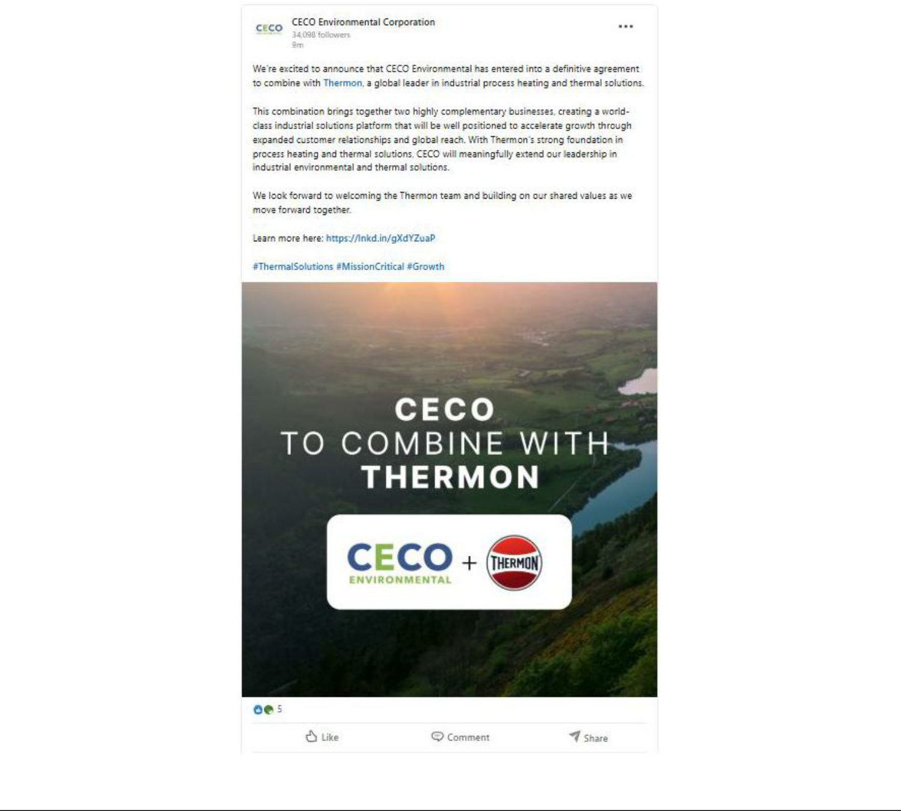

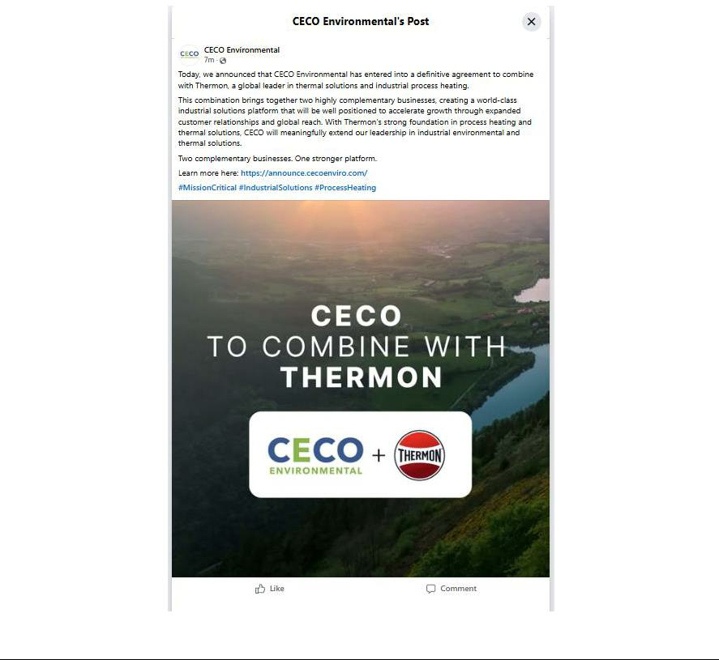

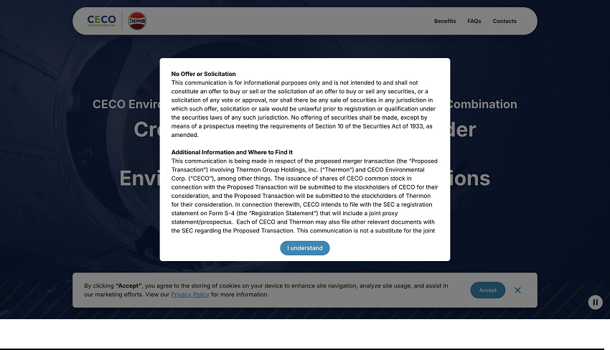

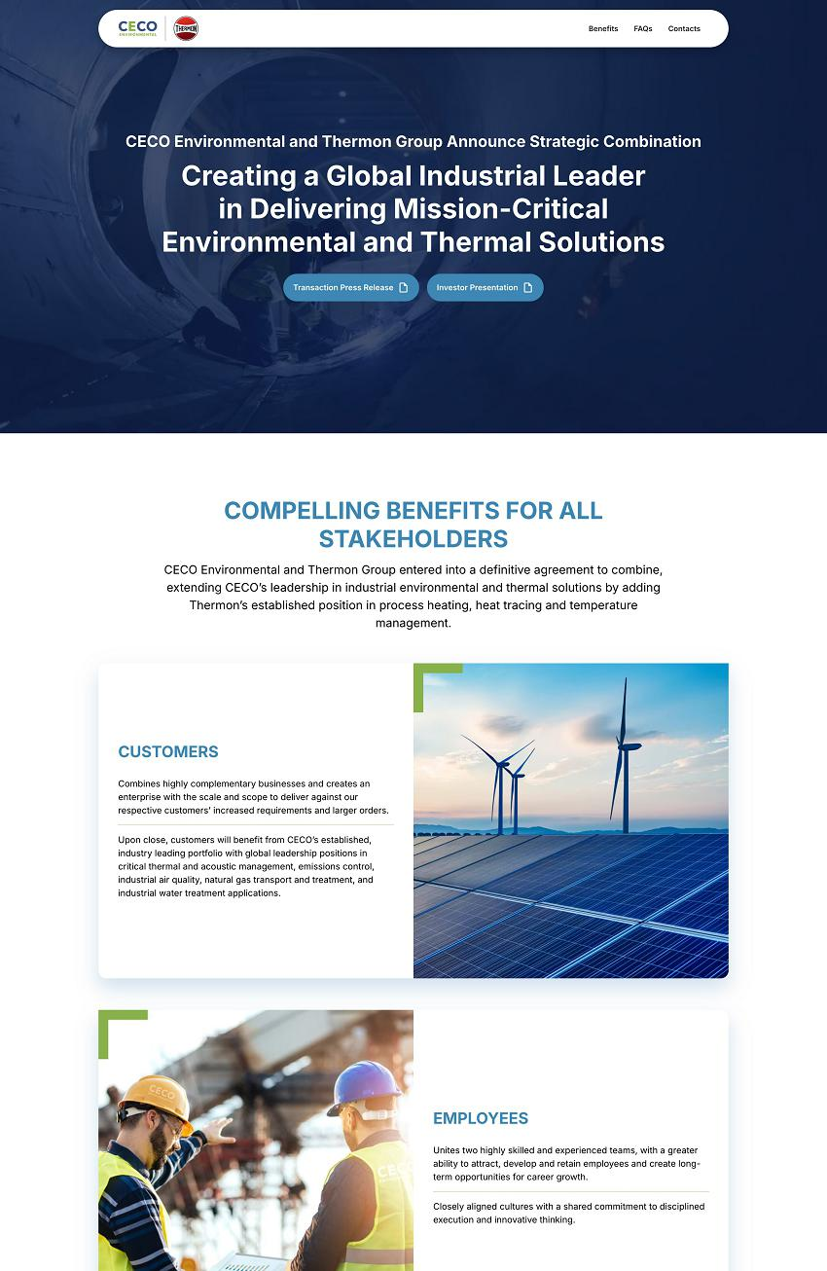

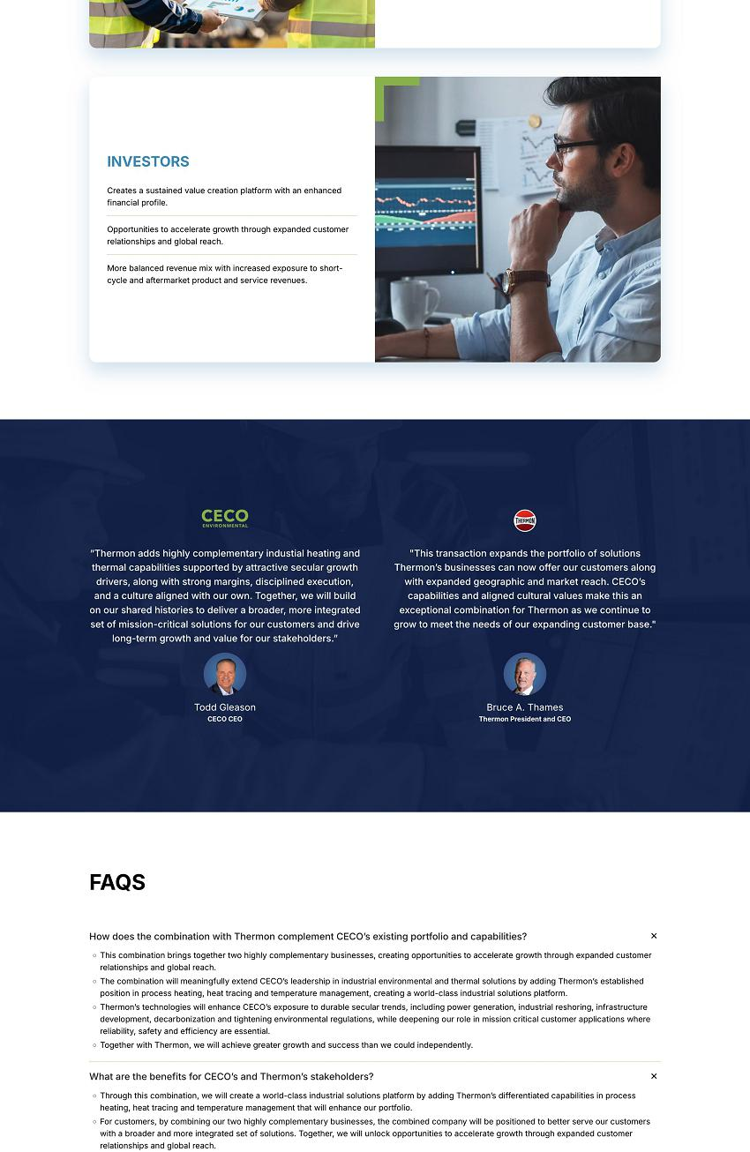

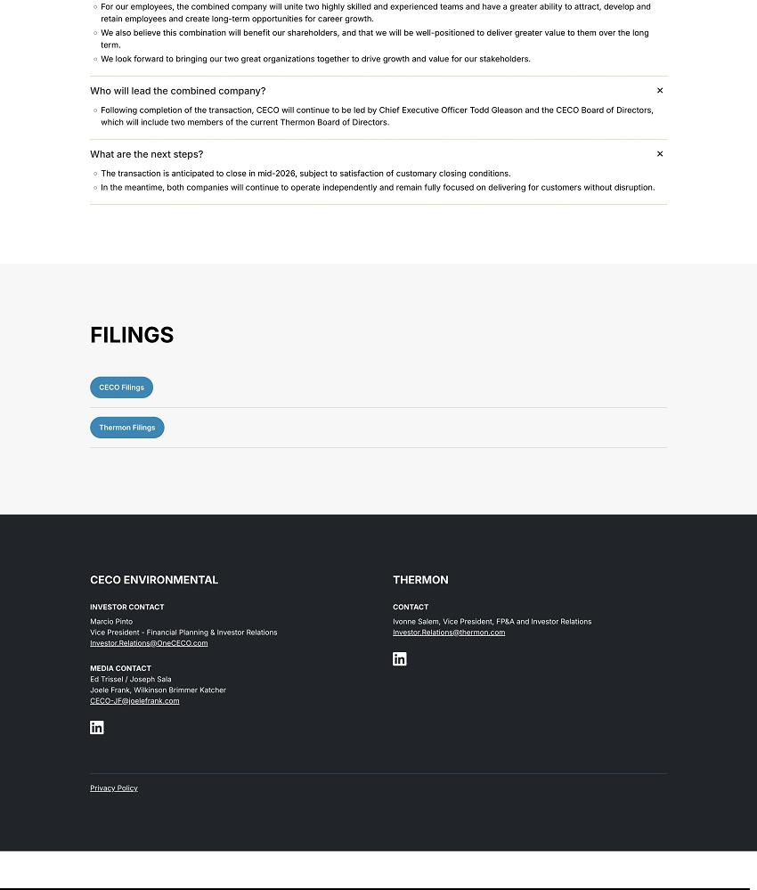

CECO Bloomberg TV Interview Transcription

Dani Burger: Turning to deal news in the industrial sector, CECO buying Thermon for $2.2 billion marking the filtration company's biggest deal ever. The takeover expands CECO's reach into thermal solutions market as demand from Data Center's fuel growth. Joining us now is Tom Gleason, CEO of CECO. Todd, thanks for joining us. Congratulations on this deal. I think first you're gonna just have to explain this to us mere mortals. I understand that you kind of exist in the ecosystem of data centers, and that's part of the reason why this is so hot, no pun intended. What exactly are thermal solutions? What are you buying and why do this deal?

Todd: Yeah, so thanks to Dani It's a pleasure being here with you today, and let me explain, any answer to the question. So first of all, both CECO Environmental and Thermon are extremely well positioned leaders and diversified industrial. So there's an attraction here that we have to expanding and bringing together, two leading companies that are really driven to provide environmental solutions for our industrial companies and customers around the world. We're each relied on every day to protect the individuals that work in those facilities, the operating processes, the natural environment. So there's a lot of just strategic and operational overlap. Then, yes, to your point, Danny, when you look at some of the hotter themes, whether it's data centers, power, reshoring, both CEO and Thermon are extremely well positioned with our legacy brands and applications and solutions to benefit, and we have been benefiting from those, our organic growth is a company, has been strong double digit now for a few years. Thermon, we believe, is really hitting its stride, not just with their legacy position, but with their innovation and investment. So, you're looking at two diversified industrial companies that are each extremely well positioned for the market as they are today, and we believe as they're going. And the synergies that come from this, both in terms of growth, and just natural cost energies, are very compelling and create a lot of shareholder value.

Dani Burger: I mean, your shares are down today, but we were just looking at your five-year price, and, I mean, you have been off, like, a rocket. Todd, how much of the business, especially with this most recent deal in hand, what is the makeup between your industrial buildout over data centers versus, I don't know, shall we call it, the old economy?

Todd: Yeah, well, it's a good question. Certainly over the last year, I think that we are a real percentage of our growth in terms of our bookings. We talk about bookings a lot more than maybe some industrial companies because 75% of our sales come from medium-to-longer cycle projects. Those projects are growing in scale with respect to natural gas power. They're growing in terms of scale, in terms of reshoring and semiconductor, a lot of natural gas infrastructure, you know, you continue to hear from CEOs and other leaders that, you know, power, gas, energy infrastructure is vital to not just the United States economy, but economies around the world. You know, a good 40% of our sales have been tied to or at least associated with things that are as in that energy and energy transition space, especially gas power and infrastructure. So, look, these are markets that for us and companies that are serving, those power markets, we have a multi mega theme a foot. It's baseline power, it's power for data centers and AI. Certainly, there's going to be headlines that move around in those themes, but the underlying need and investment is a super cycle. It may be the new arms race in terms of shoring up infrastructure and the availability of power. So, it's our largest esteem at the moment. We booked our largest order ever in the fourth quarter, $135 million project to support both thermal acoustics as well as emissions management for a large natural gas power facility that's going to be built in Texas to give you some size of what that represents. When I joined the company, a large quarter for us might be 80 or $90 million in orders, and we did that in 135 million in one order. We did over 325 million in bookings in the fourth quarter. That's not just from energy and power. That's from our global expansion and industrial footprint. We really have developed a really high-performance growth company. We believe that Thermon is just starting to hit its stride as well. The combination is powerful.

Matthew Miller: Todd, I wonder about the Environmental, the word in the name of your company. I mean, it’s just not the vibe right now fighting climate change and obviously infrastructure, energy infrastructure to power data centers is. But, do you see environment making a comeback as an important thing. I noticed you mentioned the energy transition. Are we still doing that?

Todd: Yeah, thanks Matt. So, the word ‘environmental’ for CECO represents a handful of items and while I agree that I think there have been themes associated with environment. For us, the environment represents more. First of all—and we always start with this, our clients require our products so there employees are safe. If you paint a thousand cars in a facility in a day, those volatile organic compounds need to be removed and they need to be remediated, and there’s only a handful of us that can do that. Looking at a large industrial facility, you have combustion and things that are airborne, areas within your water that need to be treated. This is less about cleaning the environment and more about protecting the environment for the employees and our customers’ multibillion investment in their equipment. So we think of the environment as safety, we think of the environment as maximization of capital investment. Oh and by the way, much of the environment is regulated or certainly industrial companies appreciate the health of their community. If you look at a natural gas power facility, the emissions that come from that can be dangerous, they’re certainly monitored and regulated. So we don’t think of ourselves as an environmental company that is going to be moving around with the themes of environment, but of safety and environmental protection.

To: CECO Investors and Analysts

From: Marcio Pinto

Subject: CECO Announces Combination with Thermon

I am reaching out to share that this morning, we announced that CECO has entered into a definitive agreement to combine with Thermon in a cash and stock transaction valued at approximately $2.2 billion. The transaction, which has been unanimously approved by the board of directors of both companies, meaningfully extends our leadership in environmental and thermal solutions by adding Thermon’s established capabilities in process heating, heat tracing and temperature management.

The combination brings together two highly complementary businesses with differentiated heating and thermal capabilities, enhancing our exposure to durable secular trends in power generation, electrification and decarbonization, energy transition and industrial reshoring.

Compelling Transaction Benefits

- The combination of CECO and Thermon is expected to result in significant strategic, operational and financial benefits.

- Combines highly complementary businesses and creates an enterprise with the scale and scope to deliver against our respective customers’ increased requirements and larger orders: The combined company will bring together two fully complementary portfolios in industrial thermal and environmental solutions, with leadership positions in attractive and growing markets.

- Provides customers with a comprehensive platform of industrial solutions designed to protect their people, equipment and processes, and the environment: Once the transaction is complete, CECO will have an industry leading portfolio with global leadership positions in critical thermal and acoustic management, emissions control, industrial air quality, natural gas transport and treatment, and industrial water treatment applications.

- Unlocks significant value through cost synergies: The combined company is expected to generate approximately $40 million of annual cost synergies within 36 months.

- Increased diversification and resilience: Following the close of the transaction, CECO will have a more balanced revenue mix with increased exposure to short-cycle and aftermarket product and service revenues.

- Creates a sustained value creation platform with an enhanced financial profile: The combined company’s direct exposure to durable global secular trends in energy transition, power generation, industrial reshoring, infrastructure development, decarbonization and tightening environmental regulations is expected to deliver strong incremental annual growth.

- Provides opportunities for employees: The combined company will unite two highly skilled and experienced teams and have a greater ability to attract, develop and retain employees and create long-term opportunities for career growth.

In a separate press release issued today, we reported our financial results for the fourth quarter and full year 2025.

We will host a conference call and webcast, today, February 24, at 8:30 AM ET to discuss the transaction along with our quarterly results. You may access the webcast, including an associated presentation, on the Investor Relations section of our website.

For more information, or to view these press releases please visit our website: www.cecoenviro.com.

Please do not hesitate to reach out to me if you have any questions. Thank you for our continued support of CECO.

No Offer or Solicitation

This communication is for informational purposes only and is not intended to and shall not constitute an offer to buy or sell or the solicitation of an offer to buy or sell any securities, or a solicitation of any vote or approval, nor shall there be any sale of securities in any jurisdiction in which such offer, solicitation or sale would be unlawful prior to registration or qualification under the securities laws of any such jurisdiction. No offering of securities shall be made, except by means of a prospectus meeting the requirements of Section 10 of the Securities Act of 1933, as amended.

Additional Information and Where to Find It

This communication is being made in respect of the proposed merger transaction (the “Proposed Transaction”) involving Thermon Group Holdings, Inc. (“Thermon”) and CECO Environmental Corp. (“CECO”), among other things. The issuance of shares of CECO common stock in connection with the Proposed Transaction will be submitted to the stockholders of CECO for their consideration, and the Proposed Transaction will be submitted to the stockholders of Thermon for their consideration. In connection therewith, CECO intends to file with the SEC a registration statement on Form S-4 (the “Registration Statement”) that will include a joint proxy statement/prospectus. Each of CECO and Thermon may also file other relevant documents with the SEC regarding the Proposed Transaction. This communication is not a substitute for the joint proxy statement/prospectus or registration statement or any other document that CECO or Thermon, as applicable, may file with the SEC in connection with the Proposed Transaction. After the Registration Statement has been declared effective by the SEC, a definitive joint proxy statement/prospectus will be mailed to the stockholders of CECO and Thermon. BEFORE MAKING ANY VOTING OR INVESTMENT DECISION, INVESTORS AND SECURITY HOLDERS OF CECO AND THERMON ARE URGED TO READ THE REGISTRATION STATEMENT, JOINT PROXY STATEMENT/PROSPECTUS AND ANY OTHER RELEVANT DOCUMENTS THAT MAY BE FILED WITH THE SEC, AS WELL AS ANY AMENDMENTS OR SUPPLEMENTS TO THESE DOCUMENTS, CAREFULLY AND IN THEIR ENTIRETY IF AND WHEN THEY BECOME AVAILABLE BECAUSE THEY CONTAIN OR WILL CONTAIN IMPORTANT INFORMATION ABOUT CECO, THERMON, THE PROPOSED TRANSACTION AND RELATED MATTERS. Investors and security holders will be able to obtain free copies of the registration statement and joint proxy statement/prospectus, as well as other filings containing important information about CECO, Thermon and the Proposed Transaction, once such documents are filed with the SEC through the website maintained by the SEC at https://www.sec.gov. Copies of the documents filed with the SEC by CECO will be available free of charge on CECO’s website at https://investors.cecoenviro.com. Copies of the documents filed with the SEC by Thermon will be available free of charge on Thermon’s website at https://ir.thermon.com. The information included on, or accessible through, CECO’s or Thermon’s website is not incorporated by reference into this communication.

Participants in the Solicitation

CECO, Thermon and certain of their respective directors and executive officers may be deemed to be participants in the solicitation of proxies in respect of the Proposed Transaction.

Information about the directors and executive officers of CECO, including a description of their direct or indirect interests, by security holdings or otherwise, is set forth in (i) CECO’s proxy statement for its 2025 Annual Meeting of Stockholders, which was filed with the SEC on April 10, 2025 (and which is available at https://www.sec.gov/ix?doc=/Archives/edgar/data/3197/000155837025004649/ceco-20250520xdef14a.htm), (ii) a Form 8-K filed by CECO on July 24, 2025 (and which is available at https://www.sec.gov/ix?doc=/Archives/edgar/data/0000003197/000095017025098303/ceco-20250718.htm), (iii) a Form 8-K filed by CECO on September 16, 2025 (and which is available at https://www.sec.gov/ix?doc=/Archives/edgar/data/0000003197/000119312525204657/ceco-20250912.htm) and (iv) to the extent holdings of CECO’s securities by the directors or executive officers of CECO have changed since the amounts set forth in CECO’s proxy statement for its 2025 Annual Meeting of Stockholders, such changes have been or will be reflected on Initial Statement of Beneficial Ownership of Securities on Form 3, Statement of Changes in Beneficial Ownership on Form 4, or Annual Statement of Changes in Beneficial Ownership on Form 5 filed with the SEC, which are available at https://www.sec.gov/cgi-bin/own-disp?action=getissuer&CIK=0000003197.

Information about the directors and executive officers of Thermon, including a description of their direct or indirect interests, by security holdings or otherwise, is set forth in (i) Thermon’s proxy statement for its 2025 Annual Meeting of Stockholders, which was filed with the SEC on June 18, 2025 (and which is available at https://www.sec.gov/Archives/edgar/data/1489096/000148909625000097/thr-20250618.htm), (ii) a Form 8-K filed by Thermon on July 1, 2025 (as amended July 15, 2025) (and which is available at https://www.sec.gov/ix?doc=/Archives/edgar/data/0001489096/000148909625000115/thr-20250701.htm) and (iii) to the extent holdings of Thermon’s securities by the directors or executive officers of Thermon’s have changed since the amounts set forth in Thermon’s proxy statement for its 2025 Annual Meeting of Stockholders, such changes have been or will be reflected on Initial Statement of Beneficial Ownership of Securities on Form 3, Statement of Changes in Beneficial Ownership on Form 4, or Annual Statement of Changes in Beneficial Ownership on Form 5 filed with the SEC, which are available at https://www.sec.gov/cgi-bin/own-disp?action=getissuer&CIK=0001489096.

Other information regarding the participants in the proxy solicitations and a description of their direct and indirect interests, by security holdings or otherwise, will be contained in the joint proxy statement/prospectus and other relevant materials to be filed with the SEC regarding the Proposed Transaction when such materials become available. Investors should read the joint proxy statement/prospectus carefully when it becomes available before making any voting or investment decisions. You may obtain free copies of these documents from CECO and Thermon using the sources indicated above.

Forward-Looking Statements

This communication contains “forward-looking statements” within the meaning of Section 27A of the Securities Act and Section 21E of the Exchange Act. All statements, other than statements of historical fact, included in this Form 8-K that address events, or developments that CECO and Thermon expect, believe, or anticipate will or may occur in the future are forward-looking statements. The words “intend,” “expect,” and similar expressions are intended to identify forward-looking statements. Forward-looking statements in this communication, but are not limited to, statements regarding the Proposed Transaction, pro forma descriptions of the combined company and its operations, integration and transition plans, synergies, opportunities and anticipated future performance. However, the absence of these words or similar expressions does not mean that a statement is not forward-looking.

There are a number of risks and uncertainties that could cause actual results to differ materially from the forward-looking statements included in this communication. These include the expected timing and likelihood of completion of the Proposed Transaction, including the timing, receipt and terms and conditions of any required governmental and regulatory approvals of the Proposed Transaction that could reduce anticipated benefits or cause the parties to abandon the Proposed Transaction, the ability to successfully integrate the businesses, the occurrence of any event, change or other circumstances that could give rise to the termination of the Merger Agreement, the possibility that stockholders of CECO or Thermon may not approve the Proposed Transaction, the risk that the parties may not be able to satisfy the conditions to the Proposed Transaction in a timely manner or at all, risks related to disruption of management time from ongoing business operations due to the Proposed Transaction, the risk that any announcements relating to the Proposed Transaction could have adverse effects on the market price of CECO’s common stock or Thermon’s common stock, the risk that the Proposed Transaction and its announcement could have an adverse effect on the ability of CECO and Thermon to retain customers and retain and hire key personnel and maintain relationships with their suppliers and customers and on their operating results and businesses generally, the risk the pending Proposed Transaction could distract management of both entities and they will incur substantial costs, the risk that problems may arise in successfully integrating the businesses of the companies, which may result in the combined company not operating as effectively and efficiently as expected, the risk that the combined company may be unable to achieve synergies or it may take longer than expected to achieve those synergies and other important factors that could cause actual results to differ materially from those projected. All such factors are difficult to predict and are beyond CECO’s or Thermon’s control, including those detailed in CECO’s annual reports on Form 10-K, quarterly reports on Form 10-Q and current reports on Form 8-K that are available on its website at https://investors.cecoenviro.com and on the SEC’s website at https://www.sec.gov, and those detailed in Thermon’s annual reports on Form 10-K, quarterly reports on Form 10-Q and current reports on Form 8-K that are available on Thermon’s website at https://ir.thermon.com and on the SEC’s website at https://www.sec.gov.

All forward-looking statements are based on assumptions that CECO or Thermon believe to be reasonable but that may not prove to be accurate. Such forward-looking statements are based on assumptions and analyses made by CECO and Thermon in light of their perceptions of current conditions, expected future developments, and other factors that CECO and Thermon believe are appropriate under the circumstances. These statements are subject to a number of known and unknown risks and uncertainties. Forward-looking statements are not guarantees of future performance and actual events may be materially different from those expressed or implied in the forward-looking statements. The forward-looking statements in this communication speak as of the date of this communication.

Neither CECO nor Thermon undertakes, and each of them expressly disclaims, any duty to update any forward-looking statement whether as a result of new information, future events or otherwise, except as required by law. Readers are cautioned not to place undue reliance on these forward-looking statements, which speak only as the date hereof.

